|  |
| --- |
| XML Legacy Conversion Project |
| ISOSTS Guidelines and Coding Instructions |

Table of Contents

1 General 5

1.1 Coding Guidance 5

1.2 File names and Ids 5

2 Structure 8

2.1 General <sec> <title> <label> 8

2.2 Front matter <front> (mandatory) 10

2.2.1 General 10

2.2.2 Metadata <iso-meta> <nat-meta> <cen-meta> 10

2.2.3 Foreword clause <sec sec-type="foreword" id="sec_foreword"> (mandatory) 11

2.2.4 Introduction clause <sec sec-type="intro" id="sec_intro"> 12

2.3 Body <body> (mandatory) 14

2.3.1 General 14

2.3.2 Clause <sec> 14

2.3.3 Scope <sec sec-type="scope" id="sec_1"> 17

2.3.4 Normative References <sec sec-type="norm-refs" id="sec_2"> 18

2.3.5 Terms and Definitions <sec sec-type="terms" id="sec_3"> 19

2.4 Back matter <back> 22

2.4.1 General 22

2.4.2 Annexes <app> 22

2.4.3 Bibliography 24

3 Text 29

3.1 General 29

3.2 Using <label> 30

3.3 Using <p> 30

3.4 Symbols 30

3.5 Subscript/Superscript <sub> <sup> 30

3.6 Using <styled-content> 30

3.7 Page footnote <fn> 31

3.8 Hyphens 32

3.9 Note or Example <non-normative-note> <non-normative-example> 33

3.10 List <list> 36

3.11 Columns <array> <table> 40

3.12 Quotation <disp-quote> 40

3.13 Graphic <graphic> 40

3.14 Coding boxed text 40

3.15 Coding <preformat> 44

3.16 Coding small caps 45

4 Formal Table <table-wrap> 46

4.1 General 46

4.2 Designation <label> <caption> <title> 46

4.3 Rows and columns <table> 46

4.4 Other Instructions for Tables 46

4.4.1 General 46

4.5 Graphical representation 47

4.6 Notes and footnotes <table-wrap-foot> <tfoot> 48

Should be coded as: 48

5 Formula <disp-formula> 49

5.1 Identifying an equation 49

5.2 General 50

5.3 Equation <mml:math> 50

5.4 Other special Instructions for Equations 51

5.5 Graphical representation 54

6 Formal figure <fig> 55

6.1 General 55

6.2 Designation <label> <caption> <title> 55

6.3 Sub-figure designation 55

6.4 Graphic <graphic> 55

6.5 Figure Key 56

6.6 For example: 56

6.7 Footnotes within the figures 57

6.8 Special Cases of figures 57

7 Term <term-sec> 59

7.1 General 59

7.2 Definition <tbx:termEntry> 59

7.2.1 <tbx:partOfSpeech> 60

7.2.2 <tbx:example> 61

7.2.3 <tbx:note> 61

7.2.4 <tbx:entailedTerm> 62

7.2.5 Cross references to the other related terms 63

7.2.6 References to the other sections of the file [within tbx coding] 63

7.2.7 Coding the source related to the term 64

7.2.8 Coding the type of the term. 65

7.2.9 subjectfield 66

8 References 68

8.1 Internal (Cross) Reference 68

8.1.1 General 68

8.2 Tables, Figures, Formulae 69

8.3 Graphics 69

8.4 Term 69

8.4.1 Footnotes 70

8.4.2 Cross-references to the items in bibliography 70

8.4.3 Other instances 71

8.5 External Reference 72

8.5.1 General 72

8.5.2 Instances where the references are not needed 72

8.5.3 Reference to standard in running text 73

8.5.4 Reference to double references in running text 73

8.5.5 Reference to standard in Normative Reference clause 74

8.5.6 Reference to standard in Bibliography 75

8.5.7 URL <uri> 76

8.5.8 <ext-link> 76

8.5.9 References that are not standards 77

9 Images 78

10 Special Cases 78

10.1 Document with different languages 78

10.2 Documents with comparisons of other standards 79

10.3 Corrigendum (Amendment documents) 83

10.4 Combination of Corrigendum and standard document structures 83

# General

## Coding Guidance

ISO's schema is based on the Journal Publishing Tag Set (JATS) version 0.4 (also known as NLM) with some modifications:

* ISO metadata in the front section
* the use of XHTML for coding tables
* the use of TBX for coding terms and definitions

The schema is designed to accommodate other documents than just standards. For this reason, many structural guidelines are not coded into the schema. Therefore, although a document must be validated against the schema, such validation does not adequately constrain the structure of a standard for coding purposes. The schema is supplemented by a set of validation rules that reflect the specific drafting guidelines for ISO standards.

Recent ISO standards should be drafted according to the ISO/IEC Directives "Rules for the structure and drafting of International Standards", 6th edition, 2011. Because the directives have changed over time and may not have always been followed faithfully, it may not be possible to apply the coding instructions described below exactly at all times. For instance, a clause described as mandatory may be absent from an older standard and other such deviations from the latest directives may exist. Wherever the document varies from the directives (and therefore from these coding instructions), the structure of the document should take precedence over the coding instructions.

For the above reasons, although the schema and validation rules may be used to validate an ISO standard, they can only be relied on definitively to identify coding errors in the most recently drafted standards. In many cases, they will only flag a variation from the latest drafting guidelines. Visual inspection is then necessary to confirm whether that variation is inherent in the original standard or due to a coding error.

Below are the coding instructions for ISO standards, based on the aforementioned ISO/IEC directives.

The coding of the structure of a standard is described first (down to the level of sections, clauses, appendices, and their labelling). This is followed by a description of the coding of various content types including: text, tables, graphics, formulae, and terms. Finally, there is a description for coding references.

## File names and Ids

The files for a standard will be provided with names that reflect the id of the standard and the format of the file contents. The converted XML document should be similarly named, retaining the standard id prefix and an ".xml" suffix (i.e. **021231~ISO_10015_1999_en.xml**).

Files associated with the converted XML document should be named according to the id of the element to which they relate. For example, "**tab_1.png**" will be the file name for the graphical representation of the formal table captioned "Table 1" in the document. This will be coded as **<table-wrap id="tab_1">**.

The following naming conventions should be used for ids and file names associated with a document:

|  |  |  |
| --- | --- | --- |
| **Element** | **File name**  (referenced by the xlink:href attribute of a <graphic>) | **id for coding**  (referenced by an <xref>) |
| Graphical representation of a formal table, identified by the number in its designation | For formal table designated "Table 1 – First Table": **tab_1.png** | **<table-wrap id="tab_1">** |
| Graphical representation of a formal figure, identified by the number in its designation | For formal figure designated " Figure 1 – First Figure": **fig_1.png** | **<fig id="fig_1">** |
| Sub-graphic (unreferenced) of a figure, numbered sequentially within the figure | For first sub-figure of formal figure 1: **fig_1.1.png** | The graphic element itself doesn’t require an id attribute but the href should use the id. **<graphic xlink:href="fig_1.1">** |
| Graphical representation of MathML, identified by its sequential position in the document | For the first MathML in the document:  **mml_m1.png** | **<mml:math id="mml_m1">** |
| Any other (unreferenced) graphic according to its sequential position in the document | For the first unnumbered graphic in the document: **img_1.png** | **<graphic xlink:href="img_1">** or **<inline-graphic xlink:href="img_1">** |
| Footnotes:  a) Document footnotes should have sequential numbering, e.g. fn_1, fn_2, etc. b) Table footnotes should have table/fn numbering, e.g. table-fn_2.4 for footnote 4 of table 2  c) Table(informal) footnotes should have table/fn numbering, e.g. table-fn_informal_2.1_1.3 for footnote 3 of first informal table in section 2.1  d) Figure footnotes do not need an id or a link because the referering text is part of the figure image. But if there is a need to reference them, e.g. the figure is marked up as a table then the id should follow the conventions for table footnotes using figure-fn as prefix. | n/a: footnotes have an id to facilitate their referencing, but are not captured as graphics | a) **<fn id="fn_1">**  b) **<fn id="table-fn_2.4>**  c) **<fn id=" table-fn _ informal_2.1_1.3”>**  d) **<fn id="figure-fn_2.4>** |

**1.2.1 Multilingual documents**

For multilingual documents **@xml:lang** should be used on the most outer block level element. For example, if a document has alternating sections in English and French, then it is sufficient to provide the @xml:lang=”en” or @xml:lang=”fr” on the top level sec element only.

# Structure

## General <sec> <title> <label>

The document is divided into three parts:

* front matter
* body
* back matter

The complete document (i.e. standard) should be coded within the root ‘standard’, which is compliant with the ISOSTS DTD.

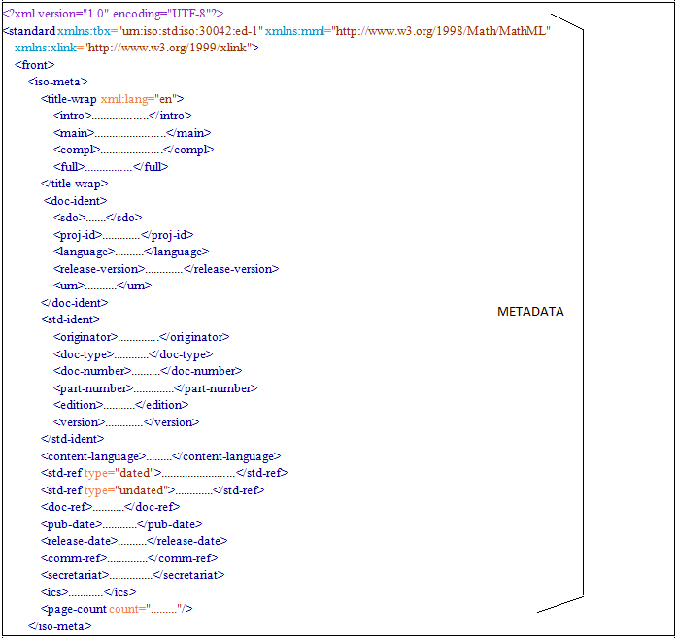For example:

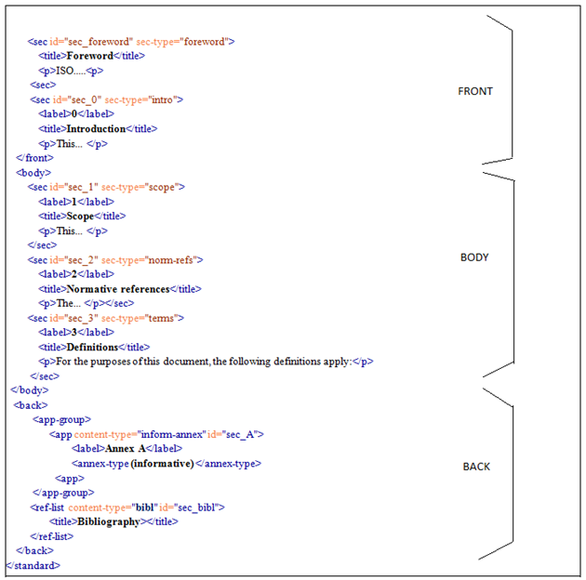

For coding purposes, the following content should be ignored from the source files (these are in the front matter and the back matter):

* title and cover pages (always appear at the beginning of the document)
* table of contents (may appear at the beginning of the document)
* page headers and footers containing the name of the document, page numbers etc. (repeated on most pages).

**Note:** The copyright notices listed in the footer should be captured in the metadata section using **<permissions>**.

* index (may appear at the end of the document) if it refers to page numbers. But the indexes refering to section numbers should be coded.

## Front matter <front> (mandatory)

### General

The Front matter contains:

* metadata including mandatory ISO metadata
* other optional national metadata
* a mandatory unnumbered Foreword
* an optional Introduction

### Metadata <iso-meta> <nat-meta> <cen-meta>

These metadata will be populated by ISO from an internal metadata database when loaded into the ISO repository. For the purposes of conversion, please provide these as blank. Only capture the copyright information in iso-meta using the **<permissions>** element.

For example:

<iso-meta>

.....

<permissions>

<copyright-statement>All rights reserved</copyright-statement>

<copyright-year>2011</copyright-year>

<copyright-holder>ISO</copyright-holder>

</permissions>

</iso-meta>

For the rest of the **<iso-meta>** elements please provide empty elements that satisfy the DTD validation. For standards with multiple copyright holders the holders can be grouped with diffferent **<permissions>** elements. The grouping should follow the grouping done in the original document.

For example:

The given copyright note in the document footer should be coded as below. The grouping is based on the different lines used in the footer.

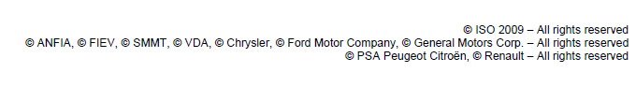

<permissions>

<copyright-statement>All rights reserved</copyright-statement>

<copyright-year>2009</copyright-year>

<copyright-holder>ISO</copyright-holder>

</permissions>

<permissions>

<copyright-statement>All rights reserved</copyright-statement>

<copyright-holder>ANFIA</copyright-holder>

<copyright-holder>FIEV</copyright-holder>

<copyright-holder>SMMT</copyright-holder>

<copyright-holder>VDA</copyright-holder>

<copyright-holder>Chrysler</copyright-holder>

<copyright-holder>Ford Motor Company</copyright-holder>

<copyright-holder>General Motors Corp.</copyright-holder>

</permissions>

<permissions>

<copyright-statement>All rights reserved</copyright-statement>

<copyright-holder>PSA Peugeot Citroën</copyright-holder>

<copyright-holder>Renault</copyright-holder>

</permissions>

For translated standards, there is no need to capture extra phrases such as "Official translation/Traducción oficial/Traduction officielle" before the ISO copyright.

### Foreword clause <sec sec-type="foreword" id="sec_foreword"> (mandatory)

This will be the first titled clause and should not be numbered. It should contain no tables or graphics. It is to be coded as a **<sec>** with a sec-type attribute of "foreword" and an id attribute of "sec_foreword".

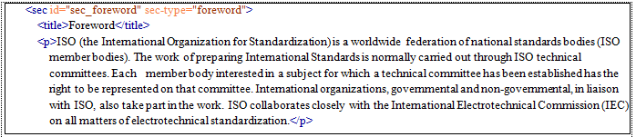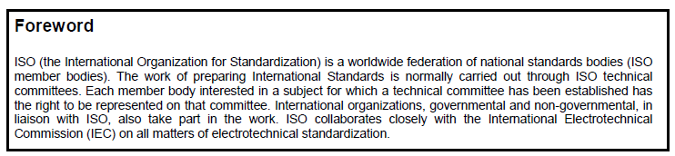For example:

Note: If there are NOTES found before the foreword section those need to be coded as follows.

And it is not needed to wrap it with <non-normative-note>

Ex: 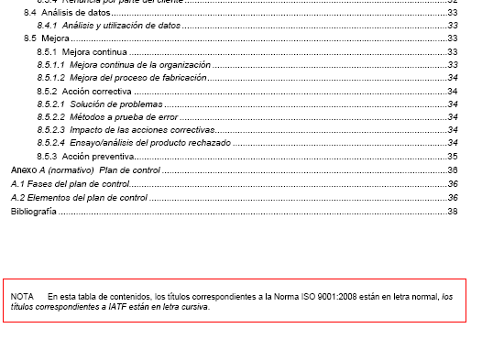

<front>

<notes>**<p>En esta…</p>**</notes>

….

### Introduction clause <sec sec-type="intro" id="sec_intro">

If present, the introduction should follow the foreword and should only be numbered (0) if it contains sub-clauses. The introduction should be coded as a **<sec>** with a sec-type attribute of "intro" and an id attribute of "sec_intro" if it is unnumbered, or "sec_0" if it is numbered 0. Any sub-clause should have an id attribute of the form "sec_0.1".

For example:

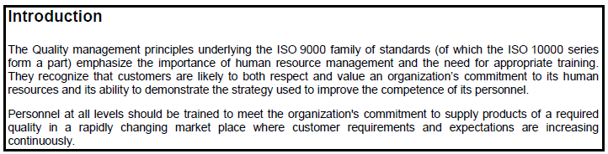a) **Unnumbered introduction section with no sub-clauses:**

should be coded as:

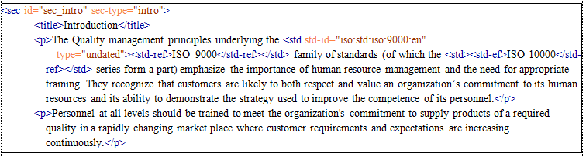

b) **Unnumbered introduction section with sub-clauses:**

If the introduction is not numbered but has sub-clauses, for the introduction use as above:

**<sec id="sec_intro" sec-type="intro">**

and for the sequence of the sub-clauses use:

**<sec id="sec_intro.1">**

**<sec id="sec_intro.1.1">**

and so on.

c) **Numbered introduction section:**

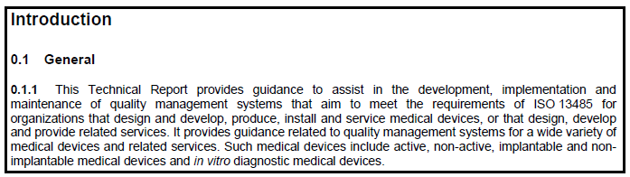Should be coded as :

<sec id="sec_0" sec-type="intro">  
 <title>Introduction</title>  
 <sec id="sec_0.1">  
 <label>0.1</label>  
 <title>General</title>

<sec id="sec_0.1.1">  
 <label>0.1.1</label>  
 <p> This Technical report......</p>  
 ............  
 </sec>  
</sec>

## Body <body> (mandatory)

### General

The body contains multiple clauses **<sec>**, always starting with clause 1 (Scope), followed by other sequentially numbered clauses, and sub-clauses numbered hierarchically.

For example: clauses 1.2.1 and 1.2.2 are within clause 1.2, which is within clause 1.

### Clause <sec>

Clauses usually contain the following:

* any type of content (text, table, graphic)
* sub-clauses.

Each clause and sub-clause should have a title and a sequential number according to its hierarchical position in the document.

The clause or sub-clause number should be coded as a **<label>** within the clause **<sec>**

The title of the clause should be coded as a **<title>** within the **<sec>**

A sec must have a label or title or both. Exceptions are sections used in corrrigenda or amendments. Here a section without an identifyable label or title should provide an empty label element (**<label/>**).

Other than some special clause types described below such as the terms and definitions clause, are to be coded using a **<sec>** without a sec-type attribute using their number coded in **<label>** and their title within **<title>**.

Clauses without a title should omit the **<title/>** element.

For example:

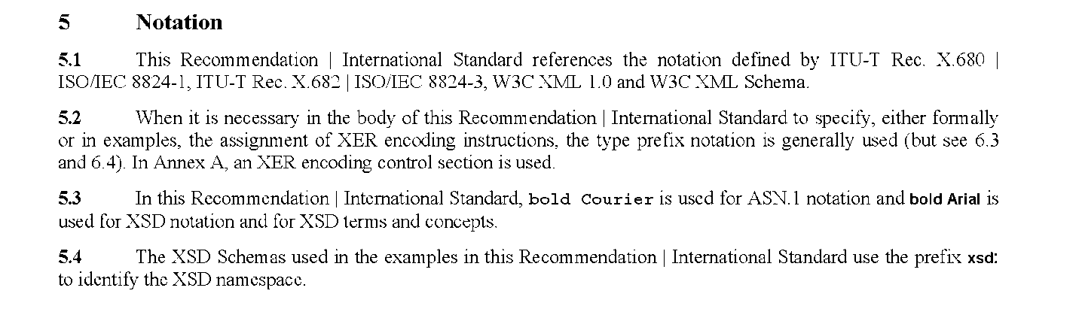

Should be coded as:

<sec id="sec_5">  
 <label>5</label>  
 <title>Notation</title>  
 <sec id="sec_5.1">  
 <label>5.1</label>  
 <p>This Recommendation | International Standard references the  
 notation defined by <std std-id="iso:std:iso-iec:8824:-1"  
 type="undated"><std-ref>ITU-T Rec. X.680</std-ref> |  
 <std-ref>ISO/IEC 8824-1</std-ref></std>, <std  
 std-id="iso:std:iso-iec:8824:-3" type="undated"  
 ><std-ref>ITU-T Rec. X.682</std-ref> |  
 <std-ref>ISO/IEC 8824-3</std-ref></std>, W3C XML  
 1.0 and W3C XML Schema.</p>  
 </sec>  
 <sec id="sec_5.2">  
 <label>5.2</label>  
 <p>When it is necessary in the body of this Recommendation |  
 International Standard to specify, either formally or in  
 examples, the assignment of XER encoding instructions, the  
 type prefix notation is generally used (but see <xref  
 ref-type="sec" rid="sec_6.3">6.3</xref> and <xref  
 ref-type="sec" rid="sec_6.4">6.4</xref>). In <xref  
 ref-type="app" rid="sec_A">Annex A</xref>, an XER  
 encoding control section is used.</p>  
 </sec>  
 <sec id="sec_5.3">  
 <label>5.3</label>  
 <p>In this Recommendation | International Standard, <styled-content  
 style="font-weight: bold; font-family: courier, monospace"  
 >bold courier</styled-content> is used for ASN.1  
 notation and <styled-content  
 style="font-weight: bold; font-family: Arial, sans-serif"  
 >bold Arial</styled-content> is used for XSD  
 notation and for XSD terms and concepts.</p>  
 </sec>  
 <sec id="sec_5.4">  
 <label>5.4</label>  
 <p>The XSD Schemas used in the examples in this Recommendation |  
 International Standard use the prefix <styled-content  
 style="font-weight: bold; font-family: Arial, sans-serif"  
 >xsd:</styled-content> to identify the XSD  
 namespace.</p>  
 </sec>  
 </sec>

Subclauses contained within the "Terms and definitions" clause should be coded as **<term-sec>** with their contents coded using TBX (See 2.3.5 and 7 for more information on the use of TBX in coding terms and definitions).

For example (note we now do not need the tbx:tig ids):



<term-sec id="sec_2.3">  
 <label>2.3</label>  
 <tbx:termEntry id="term_2.3">  
 <tbx:langSet xml:lang="en">  
 <tbx:definition>physical unit or process that removes a GHG from the  
 atmosphere</tbx:definition>  
 <tbx:tig>  
 <tbx:term>greenhouse gas sink</tbx:term>  
 <tbx:partOfSpeech value="noun"/>  
 </tbx:tig>  
 </tbx:langSet>  
 </tbx:termEntry>  
 </term-sec>

Certain clause titles indicate a specific type of clause which should be reflected in the sec-type attribute of the **<sec>** (i.e. Scope, Normative References etc.)

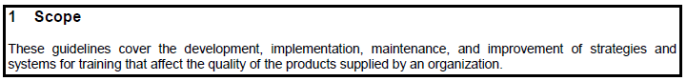For example:

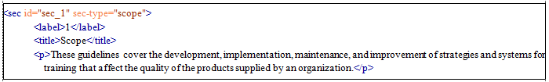Should be coded as:

The following table lists the major clauses that are normally present in a document, how they are usually numbered and titled, and how they should be identified by the sec-type attribute of the **<sec>**:

|  |  |  |  |  |  |
| --- | --- | --- | --- | --- | --- |
| **Section** | **English Title** | **French Title** | **Spanish Title** | **Russian Title** | **sec-type attribute** |
| Unnumbered **<sec>** in **<front>** | Foreword | Avant-propos | Prólogo /  Prólogo de la versión en español | Предисловие | foreword |
| **<sec>** optionally numbered 0 in **<front>** | Introduction | Introduction | Introducción | Введение | intro |
| **<sec>** numbered 1 in **<body>** | Scope | Domaine d'application | Objeto y campo de aplicación | Область применения | scope |
| **<sec>** numbered 2 in **<body>** | Normative references | Références normatives | Referencias normativas | Нормативные ссылки | norm-refs |
| **<sec>** numbered 3 in **<body>** | Terms and definitions / Terms, definitions, … | Termes et definitions / Termes, définitions, … | Тérminos y definiciones | Термины и определения | terms |
| Note: title may vary | |  |  |  |

### Scope <sec sec-type="scope" id="sec_1">

The Scope clause is normally mandatory and should be numbered 1.

For example:

Should be coded as:

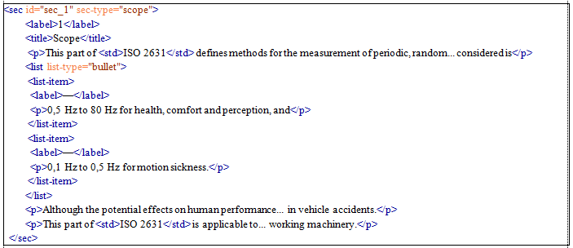

### Normative References <sec sec-type="norm-refs" id="sec_2">

The Normative References clause is normally mandatory and should be numbered 2.

If there are no normative references, the section should still contain a paragraph to that effect (i.e. stating that there are no normative references for that particular document).

If there are normative references, these should be coded as a **<ref-list>** with each reference as a **<ref>** containing a **<std>** (See 8.2 coding instructions for external references).

If a reference has a recognizable designator such as [1] (usually used in the bibliography section) then this should be coded as a **<label>** within the **<ref>**.

For example:

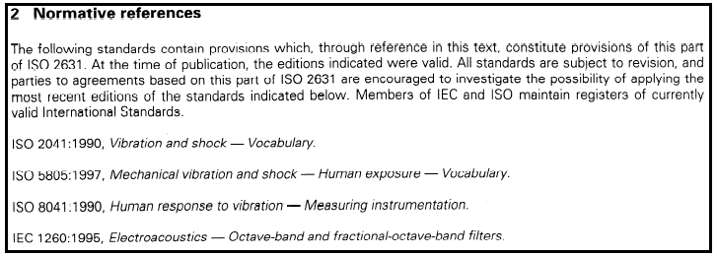

Should be coded as:

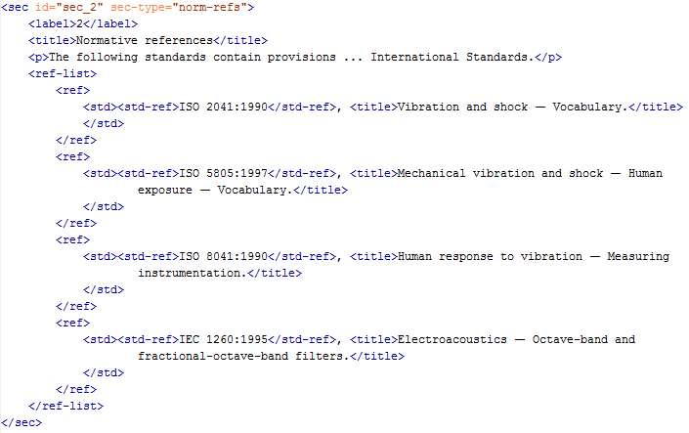

**Note:** @content-type=”standard” need to be filled for the <ref>

### Terms and Definitions <sec sec-type="terms" id="sec_3">

The terms and definitions section is an optional section in a standard. Its title may vary but should contain the words "Terms" and "Definitions" and if present, should normally be numbered 3. Only those sub-clauses that define a single term should be coded using **<term-sec>** and TBX. Other sub-clauses that it may contain should be coded as any other text clause (See 7 "Terms" for more detailed coding of this section.)

For example:

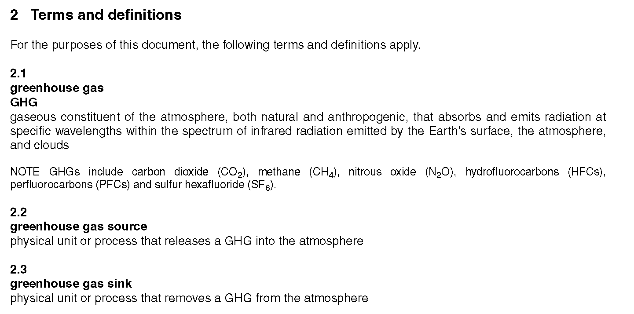

Should be coded as:

<sec id="sec_2" sec-type="terms">  
 <label>2</label>  
 <title>Terms and definitions</title>  
 <p>For the purposes of this document, the following terms and definitions apply.</p>  
 <term-sec id="sec_2.1">  
 <label>2.1</label>  
 <tbx:termEntry id="term_2.1">  
 <tbx:langSet xml:lang="en">  
 <tbx:definition>gaseous constituent of the atmosphere, both natural and  
 anthropogenic, that absorbs and emits radiation at specific wavelengths  
 within the spectrum of infrared radiation emitted by the Earth's  
 surface, the atmosphere, and clouds</tbx:definition>  
 <tbx:note>GHGs include carbon dioxide (CO<sub>2</sub>), methane  
 (CH<sub>4</sub>), nitrous oxide (N<sub>2</sub>O), hydrofluorocarbons  
 (HFCs), perfluorocarbons (PFCs) and sulfur hexafluoride  
 (SF<sub>6</sub>).</tbx:note>  
 <tbx:tig>  
 <tbx:term>greenhouse gas</tbx:term>  
 <tbx:partOfSpeech value="noun"/>  
 <tbx:normativeAuthorization value="preferredTerm"/>  
 </tbx:tig>  
 <tbx:tig>  
 <tbx:term>GHG</tbx:term>  
 <tbx:partOfSpeech value="noun"/>  
 <tbx:normativeAuthorization value="admittedTerm"/>  
 <tbx:termType value="abbreviation"/>  
 </tbx:tig>  
 </tbx:langSet>  
 </tbx:termEntry>  
 </term-sec>  
 <term-sec id="sec_2.2">  
 <label>2.2</label>  
 <tbx:termEntry id="term_2.2">  
 <tbx:langSet xml:lang="en">  
 <tbx:definition>physical unit or process that releases a GHG into the  
 atmosphere</tbx:definition>  
 <tbx:tig>  
 <tbx:term>greenhouse gas source</tbx:term>  
 <tbx:partOfSpeech value="noun"/>  
 </tbx:tig>  
 </tbx:langSet>  
 </tbx:termEntry>  
 </term-sec>  
 <term-sec id="sec_2.3">  
 <label>2.3</label>  
 <tbx:termEntry id="term_2.3">  
 <tbx:langSet xml:lang="en">  
 <tbx:definition>physical unit or process that removes a GHG from the  
 atmosphere</tbx:definition>  
 <tbx:tig>  
 <tbx:term>greenhouse gas sink</tbx:term>  
 <tbx:partOfSpeech value="noun"/>  
 </tbx:tig>  
 </tbx:langSet>  
 </tbx:termEntry>  
 </term-sec>

The following formats do not need to be coded with TBX:

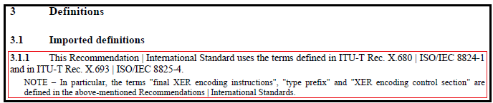

Should be coded as:

<sec id="sec_3" sec-type="terms">  
 <label>3</label>  
 <title>Definitions</title>  
 <sec id="sec_3.1">  
 <label>3.1</label>  
 <title>Imported definitions</title>  
 <sec id="sec_3.1.1">  
 <label>3.1.1</label>  
 <p>This Recommendation | International Standard uses the  
 terms defined in <std><std-ref>ITU-T Rec. X.680</std-ref> |  
 <std-ref>ISO/IEC 8824-1</std-ref></std> and in  
 <std><std-ref>ITU-T Rec. X.693</std-ref>  
 | <std-ref>ISO/IEC 8825-4</std-ref></std>.</p>  
 <non-normative-note>  
 <label>NOTE —</label>  
 <p>In particular, the terms "final XER encoding  
 instructions", "type prefix" and "XER encoding  
 control section" are defined in the  
 above-mentioned Recommendations | International  
 Standards.</p>  
 </non-normative-note>  
 </sec>

## Back matter <back>

### General

The back matter contains optional annexes, followed by an optional bibliography.

### Annexes <app>

All annexes should be coded within an **<app-group>**.

Annexes should be sequentially alpha-numbered (A, B, C etc.).

The word "Annex" and the annex number should be coded using **<label>** (excluding any trailing dash), and the title using **<title>**.

As for sections, every annex should contain a single **<label>** and **<title>** and have an id attribute of the form id="sec_A".

Each annex may contain one or more clauses and sub-clauses **<sec>** whose **<label>** and id attribute should inherit the label prefix of the parent annex, e.g. A.1, A.2, A.3.

For example:

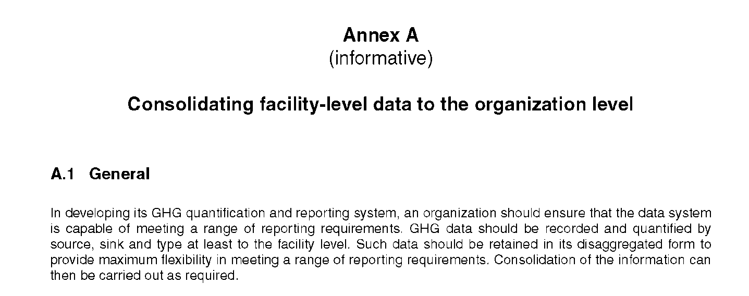

Should be coded as:

<back>  
 <app-group>  
 <app content-type="inform-annex" id="sec_A">  
 <label>Annex A</label>  
 <annex-type>(informative)</annex-type>  
 <title>Consolidating facility-level data to the organization level</title>  
 <sec id="sec_A.1">  
 <label>A.1</label>  
 <title>General</title>  
 <p>In developing its GHG quantification and reporting system, an organization  
 should ensure that the data system is capable of meeting a range of  
 reporting requirements. GHG data should be recorded and quantified by  
 source, sink and type at least to the facility level. Such data should be  
 retained in its disaggregated form to provide maximum flexibility in meeting  
 a range of reporting requirements. Consolidation of the information can then  
 be carried out as required.</p>  
 ........  
 </sec>  
 .........  
 </app>  
 </app-group>  
 </back>

**Using the Content-type attribute (@content-type) in an Annex**

1. Usually the bracketed text that follows the ‘Annex’ label, mentions whether the annex is informative or normative. This should be coded with the **@content-type**

For example:



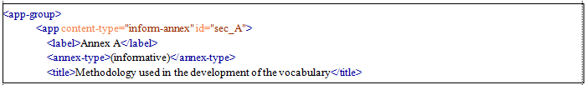Should be coded as:

The same coding is used for a normative Annex (i.e. <app content-type="**norm-annex**" id=sec_A> and with **<annex-type>**(normative)**</annex-type>**).

1. 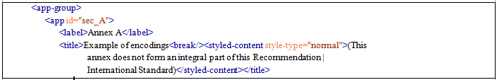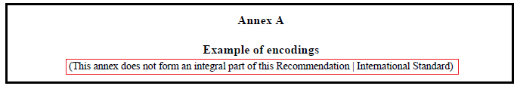When the Annex type is not informative or normative, as indicated in the following line of the title, the bracketed text should be coded as follows:

### Bibliography

The bibliography is normally the last element in the document back matter.

It should be coded using a **<ref-list> with @content-type=”bibl” and @id=”sec_bibl”**.

Each **<ref>** should contain a **<label>** followed by an **<std>** or **<mixed-citation>** according to the type of reference (see **8.5 External Reference** section for the information on coding <std> and <mixed-citation>).

The following attributes should be used for the **<ref>** element in this section.

**id** – id of the reference value =**"biblref_[value of label]”**

Note: There is no need to add the @content type to the <ref> just the **ref@id**. The ref id should be in the form of id="biblref_1"

**References for Standards in Bibliography**

For example:

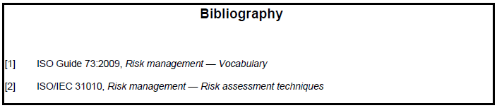

Should be coded as:

<ref-list content-type="bibl" id="sec_bibl">  
 <title>Bibliography</title>  
 <ref id="biblref_1">  
 <label>[1]</label>  
 <std><std-ref>ISO Guide 73:2009</std-ref>, <title>Risk management —  
 Vocabulary</title></std>  
 </ref>  
 <ref id="biblref_2">  
 <label>[2]</label>  
 <std><std-ref>ISO/IEC 31010</std-ref>, <title>Risk management — Risk assessment  
 techniques</title></std>  
 </ref>  
 </ref-list>

**Author names and other information in a bibliography**

For **<mixed-citation>**-type references, only the visual presentation should be replicated. There is no need for further granularity of the XML by coding author names and other details, as long as all the information is within **<mixed-citation>**.

For example:

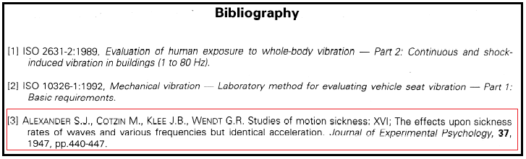

Should be coded as:

<ref-list content-type="bibl" id="sec_bibl">  
 <title>Bibliography</title>  
 <ref id="biblref_1">  
 <label>[1]</label>  
 <std><std-ref>ISO 2631-2:1989</std-ref>, <title>Evaluation of human exposure to whole-body  
 vibration — Part 2: Continuous and shock-inducedvibration in buildings (1 to 80 Hz)</title>  
 .</std>  
 </ref>  
 <ref id="biblref_2">  
 <label>[2]</label>  
 <std><std-ref>ISO 10326-1:1992</std-ref>, <title>Mechanical vibration - Laboratory method for  
 evaluating vehicle seat vibration — Part 1: Basic requirements</title> .</std>  
 </ref>  
 <ref id="biblref_3">  
 <label>[3]</label>  
 <mixed-citation xlink:type="simple">A<sc>lexander</sc> S.J., C<sc>otzin</sc> M., K<sc>lee</sc> J.B., W<sc>endt</sc> G.R.   
 Studies of motion sickness: XVI; The effects upon sickness rates of waves and various  
 frequencies but identical acceleration. <italic>Journal of Experimental Psychology</italic>,  
 <bold>37</bold>, 1947, pp.440-447.</mixed-citation>  
 </ref>

**Coding of <break/> inside mixed-citation**

The format in the example below can be coded using **<break/>** inside **<mixed-citation>**, and **<uri>** for the web addresses.

For example:

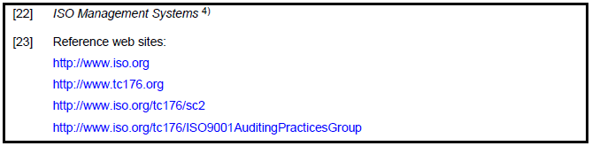

Should be coded as:

<ref id="biblref_22">  
 <label>[22]</label>  
 <mixed-citation xlink:type="simple">  
 <italic>ISO Management Systems</italic>  
 <xref ref-type="fn" rid="fn_27">  
 <sup>4)</sup>  
 </xref>  
 </mixed-citation>  
 </ref>  
 <ref id="biblref_23">  
 <label>[23]</label>  
 <mixed-citation xlink:type="simple">Reference web sites:<break/>  
 <uri xlink:type="simple">http://www.iso.org</uri><break/>  
 <uri xlink:type="simple">http://www.tc176.org</uri><break/>  
 <uri xlink:type="simple">http://www.iso.org/tc176/sc2</uri><break/>  
 <uri xlink:type="simple"  
 >http://www.iso.org/tc176/ISO9001AuditingPracticesGroup</uri></mixed-citation>  
 </ref>

**Multiple lists inside bibliography [numbering continued]**

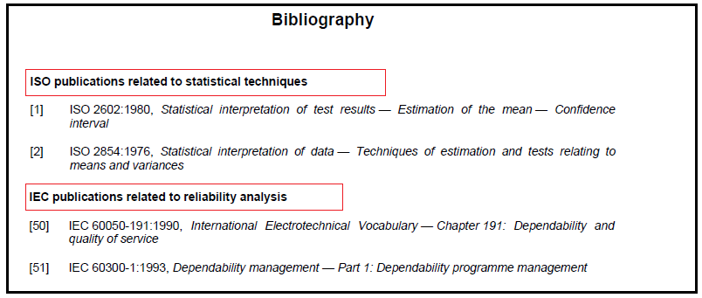

Should be coded as:

<ref-list content-type="bibl" id="sec_bibl">  
 <title>Bibliography</title>  
 <ref-list content-type="bibl">  
 <title>ISO publications related to statistical techniques</title>  
 <ref id="biblref_1">  
 <label>[1]</label>  
 <std><std-ref>ISO 2602:1980</std-ref>, <title>Statistical interpretation of test  
 results — Estimation of the mean — Confidence interval</title></std>  
 </ref>  
 <ref id="biblref_2">  
 <label>[2]</label>  
 <std><std-ref>ISO 2854:1976</std-ref>, <title>Statistical interpretation of  
 data — Techniques of estimation and tests relating to means and  
 variances</title></std>  
 </ref>

</ref-list>  
<ref-list content-type="bibl">  
 <title>IEC publications related to reliability analysis</title>  
 <ref id="biblref_50">  
 <label>[50]</label>  
 <std><std-ref>IEC 60050-191:1990</std-ref>, <title>International  
 Electrotechnical Vocabulary — Chapter 191: Dependability and quality of  
 service</title></std>  
 </ref>  
 <ref id="biblref_51">  
 <label>[51]</label>  
 <std><std-ref>IEC 60300-1:1993</std-ref>, <title>Dependability management —  
 Part 1: Dependability programme management</title></std>  
 </ref>

.......

</ref-list>

</ref-list>

**Multiple lists inside bibliography [numbering restarted]**

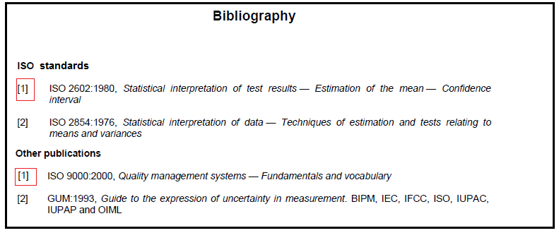Should be coded as: (note the changes in ref@id)

<ref-list content-type="bibl" id="sec_bibl">  
 <title>Bibliography</title>  
 <ref-list >  
 <title>ISO standards</title>  
 <ref id="biblref_1_1"><label>[1]</label>....</ref>

<ref id="biblref_1_1"><label>[2]</label>....</ref>

</ref-list >

<ref-list>

<title>Other Publications</title>  
 <ref id="biblref_1_1"><label>[1]</label>....</ref>

<ref id="biblref_1_1"><label>[2]</label>....</ref>

</ref-list >

</ref-list >

**Label contains words instead of numbers**

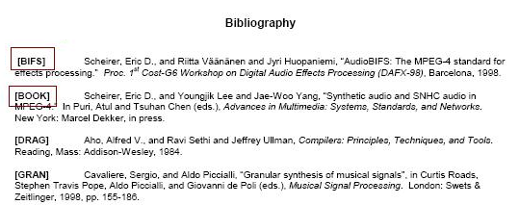

For this kind of instances, use the word for the <label>

# Text

## General

Text should be coded within **<p>** tags. Other than within formulae and tables, spacing characters (multiple spaces, line breaks, tabs) should be treated as non-significant, i.e. sequential spacing characters should be coded as a single space. Where the spacing character has been used to align a block of text into columns, then that block should be coded as a column (see below).

All punctuation characters (except soft hyphens, see below) are to be considered significant and preserved. Times New Roman (TNR), superscript, subscript, italic, bold, underlined, small caps, strike-through, mono-spaced etc. text should be coded as it appears using: **<sup>**, **<sub>**, **<italic>**, **<bold>**, **<underlined>**, **<sc>**, **<strike>**, **<monospace>** etc. tags, regardless of any semantic meaning (and additional coding) that text may have.

The non-breaking space needs to be inserted to prevent automatic line breaks ([line wrap](http://en.wikipedia.org/wiki/Line_wrap)) between two text portions. The following are a few patterns which need to be coded with non-breaking space (&#x00A0 ;).

These are usually found when the text follows/precedes numbers or numbering text such as A,B,C… or a,b,c …

Some examples:

[number] [SI Unit]

(Part)[space]([0-9])

(Partie)[space]([0-9])

([0-9])[space](%)

(ISO)[space]([0-9])

(ISO/TC)[space]([0-9])

(NOTE)[space]([0-9])

(Table)[space]([0-9])

(Equation)[space]([\((0-9)*\)])

(SC)[space]([0-9])

(Figure)[space]([0-9])

(Clause)[space]([0-9])

(Volume)[space]([0-9])

(Article)[space]([A-Z|a-z][ |\.|\)])

(Step)[space]([0-9])

(OIML)[space](D)

(Annex)[space]([A-Z|a-z][ |\.|\)])

(Annexe)[space]([A-Z|a-z][ |\.|\)])

[space](— [A-Z])

[0-9] [mathematical signs] ][0-9]

Numbers like … 1 000, the space should be placed in the space (1&#x00A0;000)

For more patterns, please refer to **Guidelines for coding non-breaking space_ISO XML Legacy Conversion Project.docx.**

## Using <label>

Retain italic and underline formatting of the label content. no need retain bold formatting

## Using <p>

Text should be coded using <p> element.

To define the alignment of an entire p the @ style-type can be used.

The values of style-type are:

* align-left
* align-right
* align-center
* valign-top
* valign-bottom
* valign-middle
* indent
* addition (give priority for using this inside <styled-content> element)

If more than one style-type should be defined we would use a semi colon separated lists,

e.g. @stype-type="align-center;valign-middle".

## Symbols

Non-alphanumeric symbols should be coded using UTF-8 codepoint. If a symbol has no UTF-8 codepoint, discuss with ISO how this should be coded properly.

## Subscript/Superscript <sub> <sup>

Superscript alpha characters normally represent a reference to a footnote. In addition to coding their appearance, the footnote references should be coded according to the guidance for coding footnote references (See 3.5, 8.1.5).

## Using <styled-content>

Styled content is usually used with @style-type.

Values for @style-type include:

* "addition" for blue and italicised text
* "normal" for plain text within a styled string of text

For example:



Should be coded as:

<app id="sec_C">  
 <label>Annex C</label>  
 <title>Illustration of real value encoding<break/><styled-content  
 style-type="normal">(This annex does not form an integral part  
 of this Recommendation | International  
 Standard)</styled-content></title>

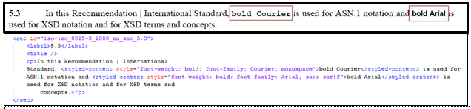However, in instances where the standard explicitly states that certain fonts should be used, <styled-content> with an attribute of @style should be used as shown below:

The Times New Roman font should be coded with the <styled-content>. When the complete document is in TNR, this is not required.

Please refer the “Guidelines for Coding TNR_ISO XML Legacy Conversion Project.docx” for more information on coding Times New Roman font in the files.

## Page footnote <fn>

Page footnotes are normally located at the bottom of an original document page. These should be coded individually within a **<fn-group>** using **<fn>** and uniquely identified via the id attribute.

Different footnote ids need to be created depending on the type of foonote:

1. For document footnotes, use sequential numbering, e.g. fn_1, fn_2, etc.

These footnotes should be numbered sequentially in the order that it occurs on the document

All the footnotes which are not related to any other structural element, such as figure, table or equation will be moved to the <fn-group> of the <back>.

Finally, the document footnote id’s get the format:

**“fn_[fn sequence within the document]”**

1. For table footnotes, use table/fn numbering, e.g. table-fn_2.4 for footnote 4 of table 2.
2. Table(informal) footnotes should have table/fn numbering:

e.g. **table-fn _ informal_2.1_1.3** for footnote 3 of first informal table in section 2.1

1. Figure footnotes do not need an ID if there is no text in the figure referencing the footnote, otherwise the numbering for the id should use the fig numbering, e.g. figure-fn_2.4 for the footnote 4 in figure 2.

**IMPORTANT:** All the document footnotes, i.e. those not related to any other structural element (such as a figure, table or equation) should be moved to the **<fn-group>** of the **<back>**.

**Ex:** suppose that the above mentioned footnotes are the 3rd and 4th footnotes in the document:

<fn-group>

**..**

<fn id=**"fn_3"**>

<label><sup>**1)**</sup></label>

<p>**this is the first footnote of the document**</p>

</fn>

<fn id=**"fn_4"**>

<label><sup>**2)**</sup></label>

<p>**this is the second footnote of the document**</p>

</fn>

</fn-group>

## Hyphens

Soft hyphens, i.e. those hyphens (not em dashes) followed immediately by a line break that are inserted purely for formatting purposes and have no meaning in text formatted differently should be removed. The latter can be recognized by a dictionary lookup: if the words either side of the hyphen do not both individually appear in the dictionary but when combined do appear as a single word, then the hyphen should be considered soft. When in doubt, all other hyphens should be preserved.

For example:

This paragraph of text demonstrates the-manner-in-which hy-ph-ens that are found should be handl-

ed when they are found within a text block.

is to be coded as:

<p>**This paragraph of text demonstrates the-manner-in-which hy-ph-ens that are found should be handled when they are found within a text block.**<p>

## Note or Example <non-normative-note> <non-normative-example>

Notes and Examples are easily recognised because they are always in a separate paragraph that starts with the word NOTE or EXAMPLE (optionally followed by a number where there is more than one sequential note).In addition, text belonging to a note or example can be set in smaller font than the rest of the text.

These should be coded as **<non-normative-note>** or **<non-normative-example>** respectively. The designation text, such as NOTE or EXAMPLE should be captured in a **<label>**, the rest of the text is to be coded with the usual elements used within sec, e.g. <p>, <list> etc..

For example:

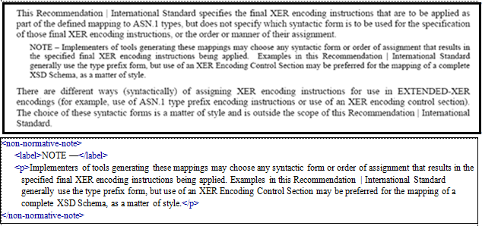

**Case 1:**

**IMPORTANT:** Any separator or number should be captured within the label, together with 'NOTE'.

**Case 2:**

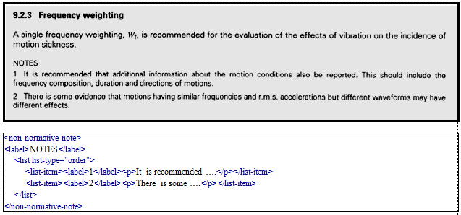

**Case 3:**

NOTE 1 This is a note

NOTE 2 This is another note

Should be coded as:

<non-normative-note>

<label>**NOTE 1**</label>

<p>**This is a note**</p>

</non-normative-note>

<non-normative-note>

<label>**NOTE 2**</label>

<p>**This is another note**</p>

</non-normative-note>

Notes may be associated with figures, tables, or formulae where they appear between the figure, table or formula and its designation, in which case the note should be coded as a paragraph within the <fig>, <table-wrap>, or <disp-formula>. For example:

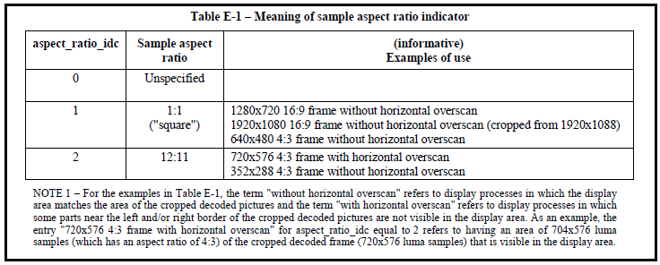

Should be coded as:

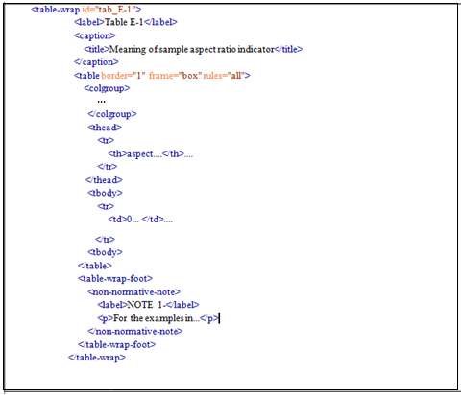

**Case 4:**

The following format should be coded with **<non-normative-example>**:

EXAMPLE This is an example

Should be coded as:

<non-normative-example>

<label>**EXAMPLE**</label>

<p>**This is an example**</p>

</non-normative-example>

**Case 5:**

Sometimes a note may be introduced by another word, such as "WARNING", in which case it should be coded as a **<non-normative-note>** with content-type attribute "warning".

For example:

WARNING This is a warning.

Should be coded as:

<non-normative-note content-type=**"warning"**>

<label>**WARNING**</label>

<p>**This is a warning**</p>

</non-normative-note>

**Case 6:**

Similarly, there can be instances with the word “IMPORTANT”.

For example:

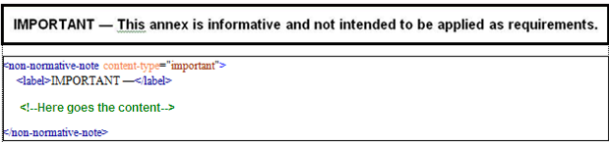

**Case 7:**

In other cases, the same format will be found as follows:

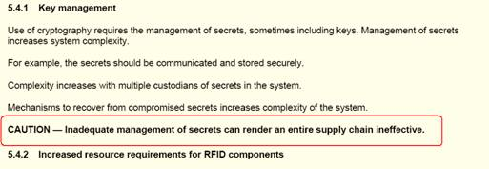

Should be coded as;

<non-normative-note content-type=**"caution"**>

<label>**CAUTION**</label>

<p>**Inadequate …ineffective.**</p>

</non-normative-note>

Above same attribute values(for @content-type) will be used for similar formats of different languages.

A note that appears within a term definition clause that is coded as **<term-sec>** should be coded using TBX according to the coding instructions for terms and definitions (See 7 "Terms").

## List <list>

A single column of indented aligned paragraphs (each paragraph normally preceded by an em dash or other repeated bullet character) should be coded as an unnumbered list using **<list>** with each paragraph of text coded as a list item using **<list-item>**.

The type of bullet characters used in the list should be coded using the list-type attribute of the **<list>**. If there is no order to the items in the list, it should be coded with the list-type as follows:

|  |  |
| --- | --- |
| **list-type="?"** | **when** |
| simple | there is no prefix character before each item |
| bullet | the same bullet, dash or other symbol appears before each item |
| alpha-lower | the prefix character is a lowercase alphabetical character: a, b, c … |
| alpha-upper | the prefix character is an uppercase alphabetical character: A, B, C … |
| roman-lower | the prefix character is a lowercase roman numeral: i, ii, iii, iv … |
| roman-upper | the prefix character is an uppercase roman numeral: I, II, III, IV … |
| order | any other ordered list, e.g. first, second, third |

In addition to identifying the type of bullet used in the list, within each **<list-item>** the actual bullet character should be captured in a **<label>** and the text within a paragraph **<p>**.

For example:

a) first item in the list

b) second item in the list

c) third item in the list

Should be coded as:

<list list-type=**"alpha lower"**>

<list-item>

<label>**a)**</label>

<p>**first item in the list;**</p>

</list-item>

<list-item>

<label>**b)**</label>

<p>**second item in the list**</p>

</list-item>

<list-item>

<label>**c)**</label>

<p>**third item in the list**</p>

</list-item>

</list>

**IMPORTANT:** All lists should be coded outside the preceding <p>.

For example:

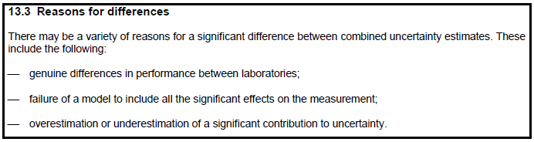

should be coded as:

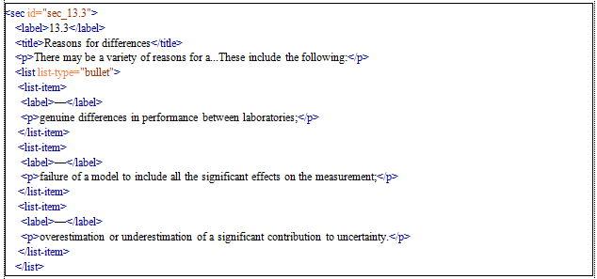

**Special indentation of text coding with list**

1. The following indentation should be maintained by coding it as a list 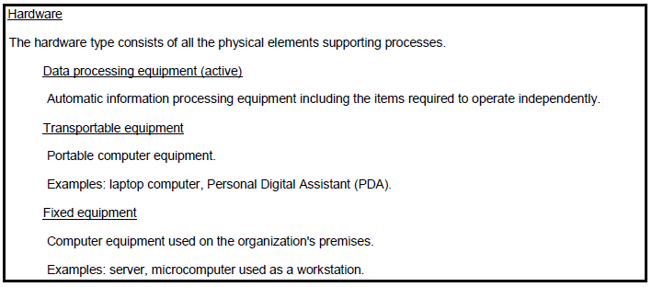

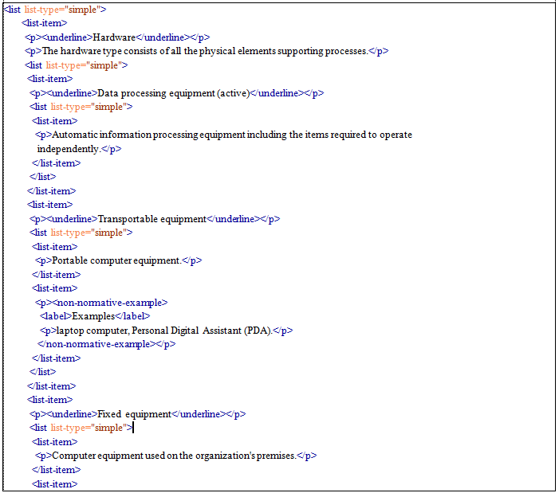

1. The following format can be coded with <list list-type="simple"> (list without bullet)

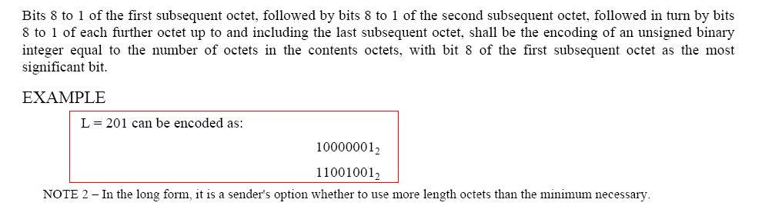

Should be coded as:

<non-normative-example>

<label>**EXAMPLE**</label>

<p>**L = 201 can be encoded as:**</p>

<list list-type=**"simple"**>

<list-item>

<p>**10000001**<sub>**2**</sub></p>

</list-item>

<list-item>

<p>**11001001**<sub>**2**</sub></p>

</list-item>

</non-normative-example>

## Columns <array> <table>

Text that is vertically aligned in more than one column and without column or row borders should be coded using **<array>** containing a **<table>** with column widths specified using the **width attribute** (@colwidth) of a **<col>** within a **<col-group>** so as to preserve the visual alignment.

For example :

Item this is an item

object this is an object

thing this is a thing

Should be coded as:

<array>

<table>

<col-group>

<col align=center col width=**"15"**>

<col align=center col width=**"30"**>

</col-group>

<tbody>

<tr><td>**Item**</td><td>**this is an item**</td></tr>

<tr><td>**object**</td><td>**this is an object** </td></tr>

<tr><td>**thing**</td><td>**this is a thing**</td></tr>

</tbody>

</table>

</array>

Such "formatting only" tables should not have the various attributes associated with formal tables (no **<table-wrap>**, **<caption>**, **<title>**, **<label>** etc.) nor should a graphical representation be captured.

## Quotation <disp-quote>

A single block of text that is indented (normally an extract or extended quote from another work that is made typographically distinct from the surrounding text) should be coded using **<disp-quote>**.

[No examples found yet]

## Graphic <graphic>

Any graphic that is not the graphical representation of a formal (numbered) figure, a formal (numbered) table, or a numbered formula is to be captured as a 300dpi PNG graphic and coded with a reference to that graphic file using the xlink:href attribute of a **<graphic>**.

For example: <graphic xlink:href="fig_A.1"/>

NOTE: the xlink:href value should only contain the basename (no extension or path) of the file.

## Coding boxed text

**Identify Boxed Text:**

**In MS Word Sources:** The text which are inserted inside a text box will be considered as boxed-text contents.

Sometimes there are contents inserted in tables with only one row and one column with a drawn border. These also can be handled as boxed text.

**In PDF Sources:** The text which are wrapped with a border and when the inside contents are not separated/formatted as rows or columns, the text will be coded as boxed-text

**In general:** If the heading of these text portions is separated by a border as in following examples, then ignore this separator line and use one boxed text element for both

* In both cases (Word & PDF), if the content inside the border has more than one or more column/row separations which are drawn by lines, the content will be coded as a table

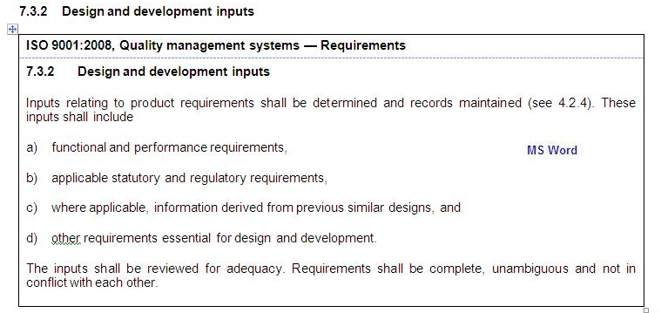

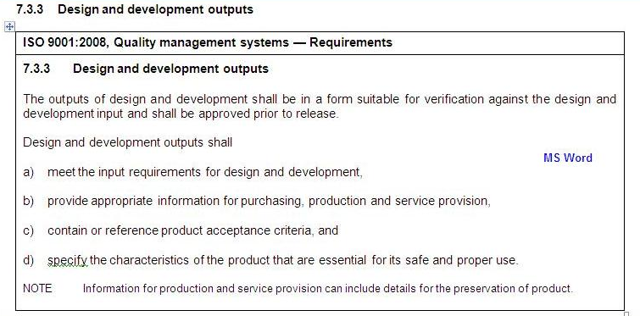

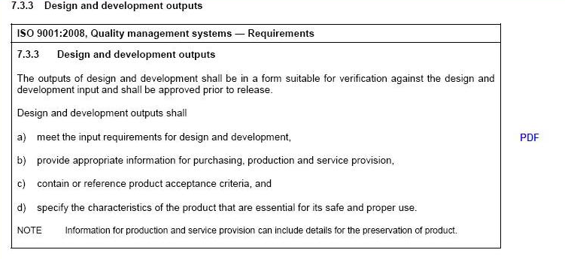

**Categorization of Boxed Text:**

There are two sorts of boxed-text:

1. **With text imported from another standard:**

When text is imported from another standard, the standard is cited in the boxed text

For this type of boxed-text, please use @content-type="foreign-source ".

It follows that filenames for scanned figures, equations and tables should have the prefix "**fs_**", e.g: **fs_fig_1.png**.

When i.ds clash, append the id with decimal point and sequential number, e.g.: **fs_fig_1.1**

1. **With text that is part of the actual standard:**

**General Instructions:**

* The heading of the boxed text should be coded with <caption><title>
* The rest of the contents of the boxed text should be coded using <p>, and do not use any structural elements such as sec, but can use the block level elements to deal with tables, figures and graphics.

Below are the block level elements which are ideal to be used inside boxed-text

* array
* boxed-text
* non-normative-note
* non-normative-example
* disp-formula
* disp-quote
* ref-list
* table-wrap
* fig
* graphic
* list
* The italicisation should also be defined.
* Visual indentation such as lists should be coded as such.
* <xref> will not be coded for the contents wrapped with boxed-text.
* <std> will not be coded for the contents wrapped with boxed-text. Only the heading of the boxed text should contain the std whenever applicable.

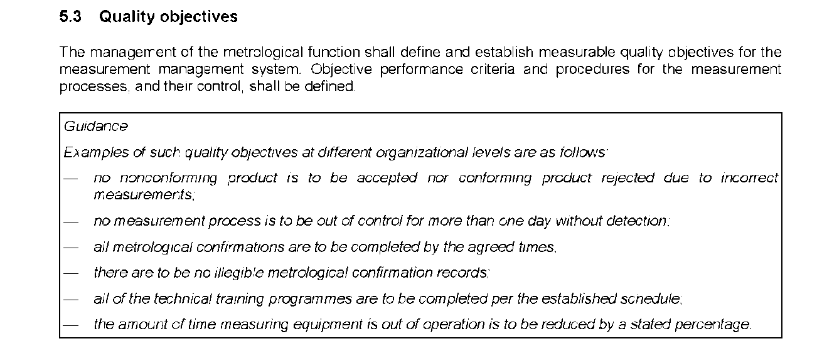

Should be coded as:

<sec id="sec_5.3">  
 <label>5.3</label>  
 <title>Quality objectives</title>  
 <p>The management of the metrological function shall define and establish measurable  
 quality objectives for the measurement management system. Objective performance  
 criteria and procedures for the measurement processes, and their control, shall  
 be defined.</p>  
 <boxed-text position="anchor">  
 <caption>  
 <title>  
 <italic>Guidance</italic>  
 </title>  
 </caption>  
 <p><italic>Examples of such quality objectives at different organizational  
 levels are as follows</italic>:</p>  
 <list list-type="bullet">  
 <list-item>  
 <label>—</label>  
 <p>  
 <italic>no nonconforming product is to be accepted nor conforming  
 product rejected due to incorrect measurements;</italic>  
 </p>  
 </list-item>  
 <list-item>  
 <label>—</label>  
 <p>  
 <italic>no measurement process is to be out of control for more than  
 one day without detection;</italic>  
 </p>  
 </list-item>  
 <list-item>  
 <label>—</label>  
 <p>  
 <italic>all metrological confirmations are to be completed by the  
 agreed times;</italic>  
 </p>  
 </list-item>  
 <list-item>  
 <label>—</label>  
 <p>  
 <italic>there are to be no illegible metrological confirmation  
 records;</italic>  
 </p>  
 </list-item>  
 <list-item>  
 <label>—</label>  
 <p>  
 <italic>all of the technical training programmes are to be completed  
 per the established schedule;</italic>  
 </p>  
 </list-item>  
 <list-item>  
 <label>—</label>  
 <p><italic>the amount of time measuring equipment is out of operation is  
 to be reduced by a stated percentage</italic>.</p>  
 </list-item>  
 </list>  
 </boxed-text>  
 </sec>

## Coding <preformat>

For the types of program codes shown below, **<preformat preformat-type="code">** and **<styled-content style="font-weight: bold; font-family: Courier, monospace">** should be used.

Normally **<preformat preformat-type="code">** would be sufficient for any source code, but because the typography was highlighted in the notation section, it should be retained for the actual content. The text should be captured with the same spacing and indentation.

The indentation for the starting point does not need to be retained, as this will be handled post-conversion.

This is applicable for the text formats shown below:

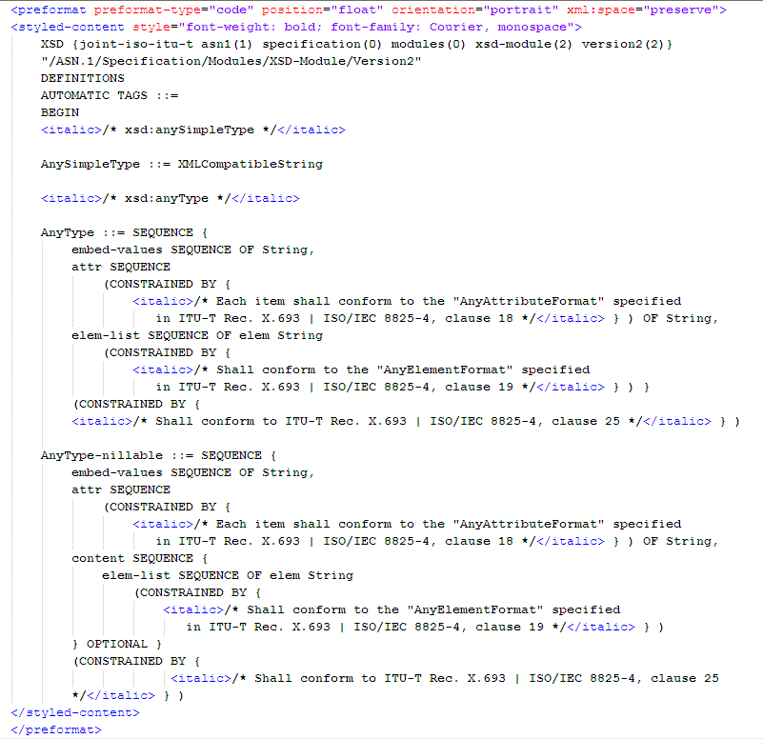

## Coding small caps

The element **<sc>** is used to mark text that should appear in a font that creates smaller capital letters. The letters inside the tag should be coded in lowercase. Only the letters which need to be converted to smaller capital should be included into the tag

For example:

|  |
| --- |
| <p>**... Sequence comparisons with programs**<sc>**gapped blast**</sc> **and**  <sc>**psi-blast**</sc> **and 434100**  **sequences of databases did not find ...**</p> |

# Formal Table <table-wrap>

## General

A formal table may be recognized by being preceded by a centered designation "Table # - Title" with an optional title. Anything that appears between designation and any notes that are related to and following the body of the table should be coded within the **<table-wrap>**.

Tables should be coded using XHTML so as to preserve as far as possible their visual representation.

Borders and shading should be represented using the style attribute of the respective table element tags. The width of table columns should be defined by a **<col >** within the **<table>**, with the width of each column captured as an absolute number of pixels using the width attribute.

## Designation <label> <caption> <title>

A table designation should normally be at the top of the table in the form "Table 1 – Title of Table". The title should be coded as a **<title>** within a **<caption>**. The rest of the designation should be coded as a label (excluding the trailing dash).

The number of the table should also be captured and coded as an id attribute to the **<table-wrap>**.

Tables which do not have a label should be coded with the following id for <table-wrap>

Id=tab_informal_[sectionnumber]_[informal_table_sequence_within_section]

## Rows and columns <table>

Tables should be coded using the XHTML 1.1 table model, including the coding of table headers (rows or columns that describe the contents of other rows or columns) and footers using **<thead>** or **<tfoot>**.

**IMPORTANT:** Nested tables are not permitted.

The text content of cells should be coded according to the instructions for coding text, except that spacing and line breaks should be handled differently. Line breaks that indicate the presence of merged or split cells in a row should be reflected in the coding of those cells using column or row span tags. Spacing that causes the text in a cell to be aligned, should be reflected in the alignment coding of those cells.

## Other Instructions for Tables

### General

1. For more detailed information on the tables, Please refer the **Guidelines for Coding Tables_ISO XML Legacy Conversion Project.docx**
2. The two column figure-key tables available in the MS Word Files are inserted as 4 column tables. The extra two columns need to be removed from the coded tables.
3. Sometimes the information of the table will be described under the heading “where”.

Ex:

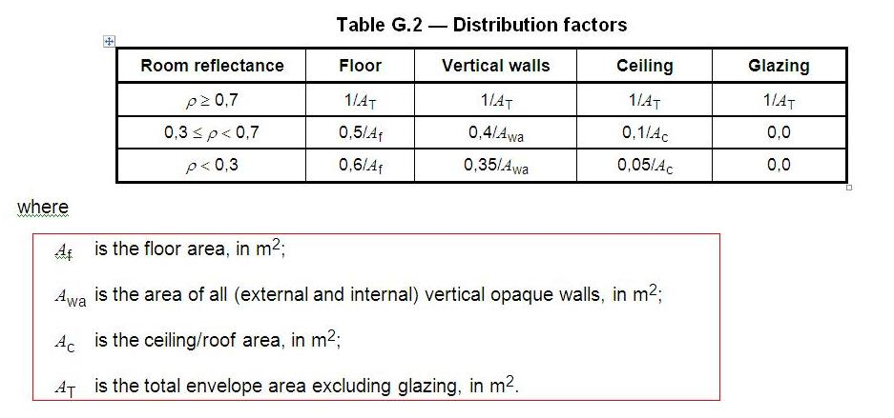

Such formats should be coded as a separate table-wrap with type;

@contenttype="table-index"

1. When a table contains a text which describes the units used in the table it should be captured as **<p>** in **<table-wrap-foot>**



1. The presentation of the following kind of cells should be altered as mentioned below:



Should be rebuilt as:



And coded accordingly.

## Graphical representation

The rows and columns of the table, i.e. that part which is coded within the **<table>** and which excludes the designation and any notes, should also be captured as a 300dpi PNG graphic file which should be named (renamed if provided) to match the id of the table, e.g. **tab_1.png** for table 1.

The informal tables also should have the corresponding image with the relevant id.

If there are multiple such graphics (which may be the case if the table spans more than one page) then these shall be captured as separate files numbered **tab_1.1.png** , **tab_1.2.png** etc. The names of the graphics files should not be coded in the xml.

## Notes and footnotes <table-wrap-foot> <tfoot>

Notes or footnotes that appear between the table and the designation should be associated with the table by being coded them within a <tfoot> or <table-wrap-foot> within the <table-wrap>.

Table footnotes (footnotes that appear between the table and its designation) should be coded using **<fn>** with an id attribute prefixed with "**table-fn**" instead of "fn"

The id should be in the following format

Formal tables: **table-fn_[table footnote sequence within the document]**

Informal tables: **table-fn_[id of the informal table].[fn sequence within the table]**

For example, for footnote 4 of table 2: table-fn_2.4.

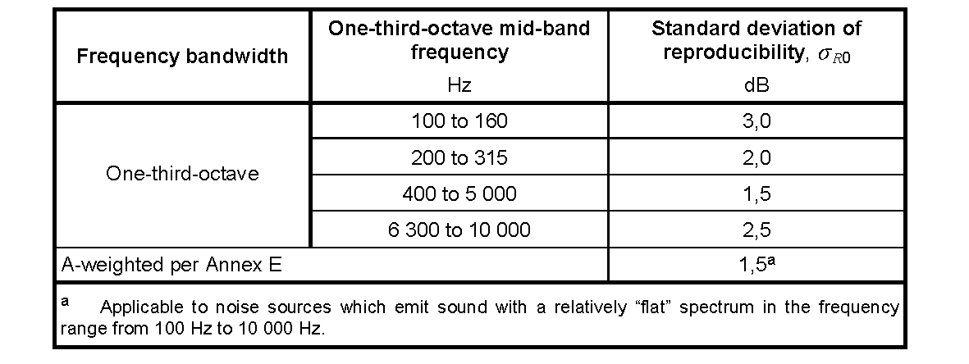

## Should be coded as:

<table-wrap id="tab_2">  
 <label>Table 2</label>  
 <caption>  
 <title>Typical upper bound values of the standard deviation of reproducibility of the method,  
 <italic>σ</italic><sub><italic>R</italic>0</sub>, for sound power levels and sound energy  
 levels determined in accordance with this International Standard</title>  
 </caption>  
 <table border="1" frame="box" rules="all">  
 <colgroup>  
 <col align="center" valign="middle" width="112.35"/>  
 <col align="center" valign="middle" width="130.40"/>  
 <col align="center" valign="middle" width="130.40"/>  
 </colgroup>  
 <thead>  
 <tr>  
 <th>Frequency bandwidth</th>  
 <th>One-third-octave mid-band frequency<break/><styled-content style="normal"  
 >Hz</styled-content></th>  
 <th>Standard deviation of reproducibility, <styled-content style="normal"  
 ><italic>σ</italic><sub><italic>R</italic>0</sub></styled-content><break/><styled-content  
 style="normal">dB</styled-content></th>  
 </tr>  
 </thead>  
 <tfoot>  
 <tr>  
 <td align="left" colspan="3">  
 <fn id="table-fn_2.1">  
 <label>  
 <sup>a</sup>  
 </label>  
 <p>Applicable to noise sources which emit sound with a relatively “flat” spectrum in the  
 frequency range from 100 Hz to 10 000 Hz.</p>  
 </fn>  
 </td>  
 </tr>  
 </tfoot>  
 <tbody>  
 <tr>  
 <td rowspan="4">One-third-octave</td>  
 <td>100 to 160</td>  
 <td>3,0</td>  
 .....................................  
 </tr>  
 <tr>  
 <td align="left" colspan="2">A-weighted per Annex E</td>  
 <td>1,5<xref ref-type="table-fn" rid="table-fn_2.1"><sup>a</sup></xref></td>  
 </tr>  
 </tbody>  
 </table>  
 </table-wrap>

# Formula <disp-formula>

## Identifying an equation

Equation is an expression that contains an **equal sign** and one or more math operator on either side of the equal sign.

Ex: Following can be considered as equations

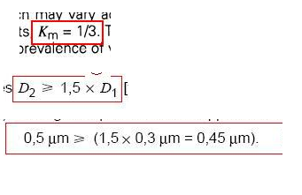.

Ex: Following can not be considered as equations

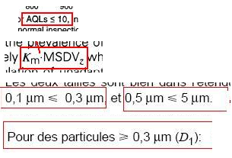

## General

Single terms without operators that appear within the flow of text should be coded as normal text, formatted as they appear in the text, including font information (e.g, TNR).

A formula/equation should be coded using <disp-formula> if it is visually separate from the surrounding text, or using **<inline-formula>** if it is embedded in the flow of the text that surrounds it.

One or more formulae with shared notes should be contained within a **<disp-formula-group>** to ensure that the notes are associated with the formulae.

A single formula without associated notes does not need to be contained in a **<disp-formula-group>**.

## Equation <mml:math>

The equation or mathematical expression within the **<disp-formula>** or **<inline-formula>** should be coded using **<mml:math>** so as to preserve as closely as possible its visual representation, including spacing.

No detailed instructions are provided for the coding of MATHML as it is assumed that this will be done by a specialized WYSIWYG tool that will generate the codes automatically.

Every formula captured as MathML should have an id prefixed "mml_m" according to its sequential position in the document (Having unique id’s is the ultimate requirement), for example:

<disp-formula id=**"formula_3"**>

<mml:math id=**"mml_m5"**>

</mml:math>

</disp-formula>

Visually separated formula may optionally be numbered to facilitate references by a number in parentheses, e.g. (1), to the right of the formula. Formula numbers are usually sequential and numbered independently of any containing clauses.

The number of the formula should be captured in the id attribute of the **<disp-formula>**, e.g. **<disp-formula id="formula_1">** for a formula numbered 1, so that it can be referenced. The formula number should also be captured as a **<label>** within the **<disp-formula>**, e.g.

<disp-formula id=**"formula_1"**>

<label>**(1)**</label>

<mml:math id=”**mml_m3”**>

</mml:math>

</disp-formula>

## Other special Instructions for Equations

1. **Using @display**

In order to retain the proper layout the of the equations with **sum function,**  the attribute @display="block" should be used. This will be applied for both "inline-formula" and "disp-formula"

Using this attribute for the coding will visualize the equation as center aligned in the page. This layout difference is acceptable from clien’t end.

1. **Spaces within equation/formula text**

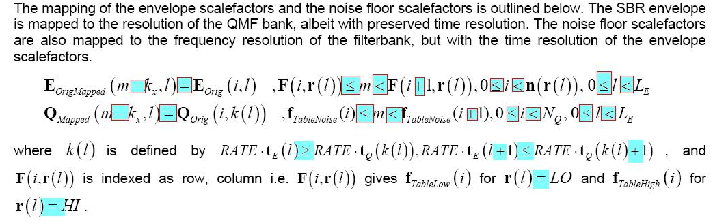

When in doubt whether there are spaces next to the operators, always add spaces on both sides of an operator/comparator.

Ex: highlighted in the example above

For the other spaces before and after punctuations, please use your own judgment as to where to add a space in order to retain the visual.

1. Following format should be coded as follows:

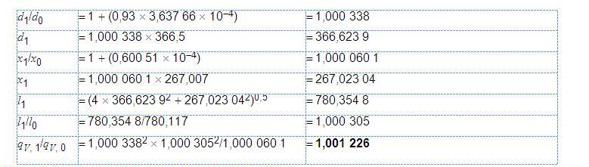

Since each and every line of the table is an equation, the lines should be coded as equations.

Considering the layout, the complete portion should be coded as a one column table(array) and the equations should be coded with <inline-formula> inside <td>

1. Instances such as follows, where the same equation is derived for values and the calculations are done in a format where the equal sign is aligned, the text should be coded as a table without coding the complete sections as an equation.

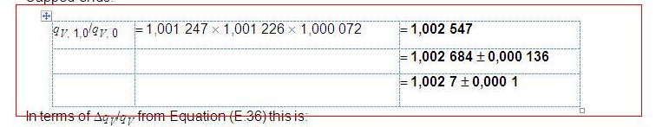

1. For the equations which has more than one line with values, the following method need to be used. For example;

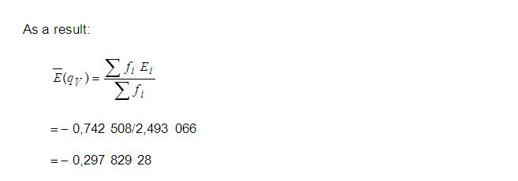

The layout of the equation should be retained by coding the equation as a math array. mml:mspace can be used to retain the spaces. All the lines of the equation should be included in the mml file

And the corresponding image of the equation should contain all the lines of the equation as one image

1. In following instances, the stand-alone equation contain related other information in-line to the equation.

**Case1:** Information found separated with a comma and need to be coded with mathml

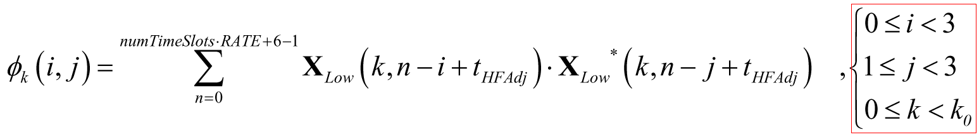

**Case2:** Information found separated with commas and can be coded with pcdata as well

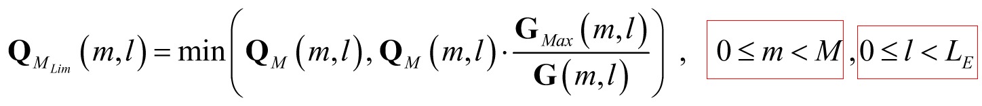

**Case3:** information found inline, but not separated with a comma and can be coded as pcdata as well

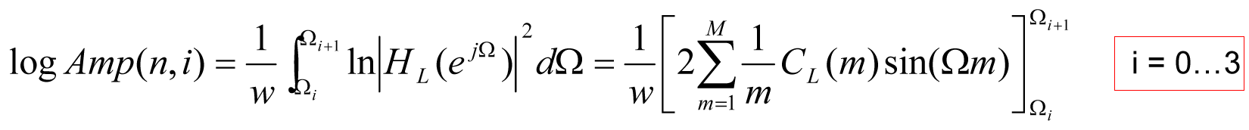

All above instances should be

* coded under the same mml:math where the main equation is coded.
* the comma(s) should also be included in the math section.
* one image should be created capturing the complete portion with the equation.
* complete section should be coded in one <disp-formula>

**Case4:**

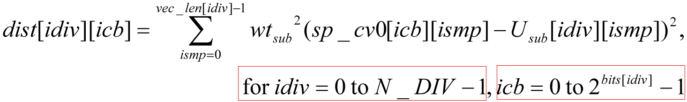

In the above case where the related information of the equation is found in a separate line, should be coded using math array. And still be included in a one image and under same math id of the main eqiuation.

## Graphical representation

MathML should also be captured as a 300dpi graphic file in PNG format.

For example, the 5th MathML formula in the document will have id="mml_m5" and will be captured as **mml_m5.png**.

The names of the graphics files should not be coded in the XML.

The ‘Where’ table found after the equation should be coded as in the following image with table-wrap@content-type=”formula-index”

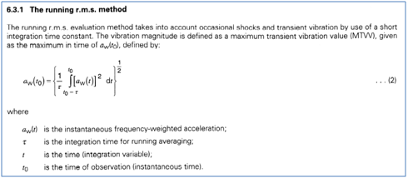

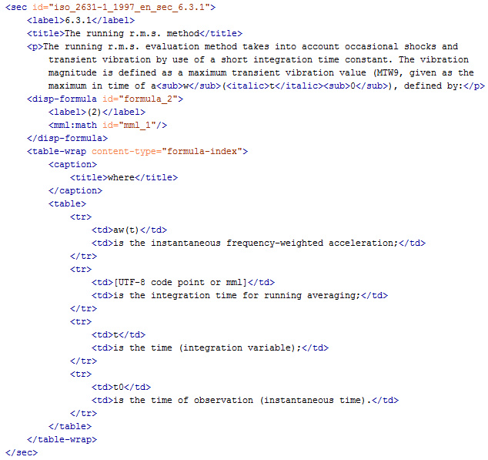

# Formal figure <fig>

## General

A formal figure may be recognized by being followed by a centered designation "Figure # - Title of Figure" and should be coded using **<fig>**, e.g:

**Figure 3 - Medical Devices**

Notes that may appear between the body of the figure and its designation should be coded using <non-normative-note> within the **<fig>**.

The graphic contained within a formal figure should be coded using **<graphic>**. If the formal figure contains multiple graphics (each with their own sub-caption) then each graphic should be captured as a separate **<graphic>** within the **<fig>**.

## Designation <label> <caption> <title>

A formal figure designation should normally be in the form "Figure 1 – Name of Figure" The title should be coded as a **<title>** within a **<caption>** within the **<fig>**. The rest of the designation should be coded as a label (excluding any trailing dash). The number of the figure should also be captured and coded as an id attribute to the **<fig>**:

<fig id=fig_1>

<label>**Figure 1**</label>

<caption>

<title>**Name of Figure**</title>

</caption>

</fig>

## Sub-figure designation

The caption of a sub-figure may be of the form "a). title of sub-figure" and should be coded with the caption as a **<title>** within a **<caption>** within the **<graphic>**. The <graphic> for each sub-figure should have an id attribute using an identifiable identifyer of the sub figure, e.g. fig_1.a, or simply use its sequential position in the figure, for example the first sub-figure in figure 1 should have an id "fig_1.1". The rest of the sub-figure caption should be captured as a label within the **<graphic>** (excluding any trailing dash), for example:

<graphic xlink:href=**"fig_1.1"** id=**"fig_1.1"**>

<label>**a).**</label>

<caption><title>**title of sub-figure**</title></caption>

</graphic>

## Graphic <graphic>

If provided as an external graphics file, that file should be referenced in a **<graphic>**.

If available only as an inline graphic, the graphic should be captured as a 300 dpi PNG graphic file (excluding the designation and title, and any key, or notes) and referenced in a **<graphic>**. The graphic elements of a figure should be captured in as few graphic files as possible - preferably as a single graphic, unless those elements are separated by a codeable text element such as a note or key. The graphic file should be named (or renamed if provided) to match the id of the figure, e.g. fig_1.png for figure 1.

If there are multiple graphics associated with the figure these should be numbered fig_1.1, fig_1.2 etc. The xlink:href attribute of the **<graphic>** should not contain the file extension in order to facilitate the use of multiple image formats during the rendering process, e.g.

<graphic xlink:href="fig_1.1"/>

## Figure Key

A figure key is recognized by being preceded by the title "Key". It should be coded using **<table-wrap>** with a content-type attribute of "fig-index" within the **<fig>** and coded as text according to its formatting. If the key contains any graphical elements these should be captured using **<graphic>** or **<inline-graphic>** according to the coding instructions for graphics within text.

## For example:



Key

A1 First Item A3 Third Item

A2 Second Item A4 Fourth Item

NOTE A note about this figure

Figure 1 – Example circuit

Should be coded as

<fig id=**"fig_1"**>

<label>**Figure 1**</label>

<caption>

<title>**Example circuit**</title>

</caption>

<graphic xlink:href=**"fig_1 "**/>

<table-wrap content-type=**"fig-index"**>

<caption><title>**Key**</title></caption>

<table>

<colgroup>

<col width=15/>

<col width=150/>

<col width=15/>

<col width=150/>

</colgroup>

<tbody>

<tr>

<td>**A1**</td>

<td>**First Item**</td>

<td>**A3**</td>

<td>**Third Item**</td>

</tr>

<tr>

<td>**A2**</td>

<td>**Second Item**</td>

<td>**A4**</td>

<td>**Fourth Item**</td

></tr>

</tbody>

</table>

</table-wrap>

<non-normative-note>

<label>**NOTE** </label>

<p>**A note about this figure**</p>

</non-normative-note>

</fig>

## Footnotes within the figures

Footnotes found with the figures should be coded with **<fn-group>** & **<fn>**.

Figure footnotes do not need an ID if there is no text in the figure referencing the footnote, otherwise the numbering for the id should use the fig numbering, e.g. figure-fn_2.4 for the footnote 4 in figure 2.

## Special Cases of figures

1. The following figure contains two tables with different color codes. This needs to be migrated as a table and therefore, the key table also needs to be coded as a table

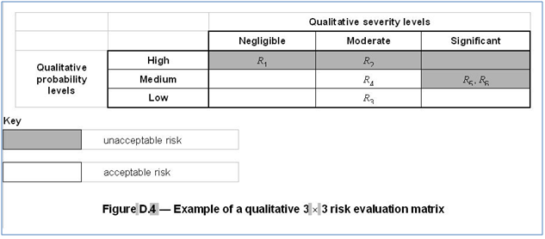

**IMPORTANT:**

1. This is also true for the Key table.
2. The image for the main table will be named using the table-wrap@id as fig_D.4.1
3. The following figure contains a text which describes the units used in the image.

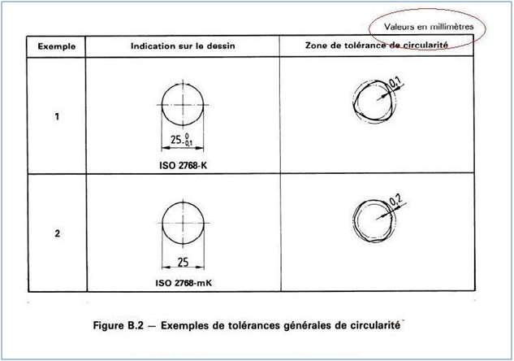

This text should be captured as a **<p>** with **attribute style-type=”align-left”**before the **<graphic>** element.

1. In order to retain the layout of the images, follow the following codes.

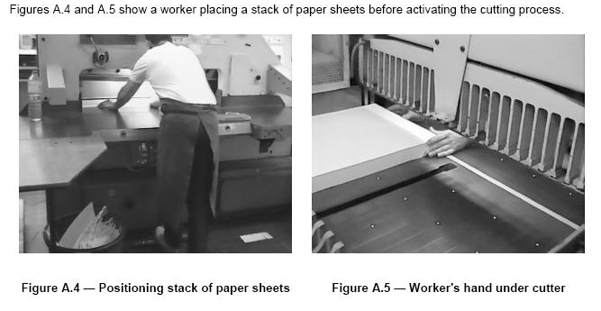

<fig-group position=**"anchor"**>

<fig id=**"fig_A.4"** position=**"float-left"**>

**....**

</fig>

<fig id=**"fig_A.5"** position=**"float-left"**>

**...**

</fig>

</fig-group>

# Term <term-sec>

## General

Only those term definitions that occur in the section with sec-type="terms" should be coded as described here. Terms that appear elsewhere in the document should be coded as any other text clause. Each clause that defines a term should be coded into a separate sequentially numbered <term-sec> with the number of the clause in a **<label>**. The **<term-sec>** should also have an id that matches the clause number. Unlike other clauses whose titles are coded with **<title>** within the **<sec>**, titles of a **<term-sec>** clauses are not coded in this way as they are coded within the contained TBX.

## Definition <tbx:termEntry>

The text of a term and its definition (and any associated note) are coded using TBX into a **<tbx:termEntry>**. The clause number is to be used for the id attribute of the **<tbx:termEntry>** prefix with “term_”, e.g. term_3.1.

For example:

<term-sec id=**"sec_3.1"**>

<label>**3.1**</label>

<tbx:termEntry id=**" term_3.1"**>

**...**

</tbx:termEntry>

</term-sec>

The colon found after the term should be ignored. Only the bold part is the **tbx:term** and the rest is the **tbx:definition**.

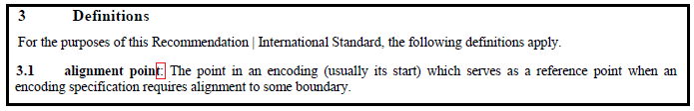For example:

Should be coded as:

|  |
| --- |
| <term-sec id="sec_3.1">  <label>3.1</label>  <tbx:termEntry id="term_3.1">  <tbx:langSet xml:lang="en">  <tbx:definition>The point in an encoding... boundary.</tbx:definition>  <tbx:tig>  <tbx:term>alignment point</tbx:term>  <tbx:partOfSpeech value="noun"/>  </tbx:tig>  </tbx:langSet>  </tbx:termEntry>  </term-sec> |

Usually the term will be visible in bold. Eevn when it is not in bold formatting, it can be coded with <tbx:term>. It is not needed to render the non-bold formatting for terms.

### <tbx:partOfSpeech>

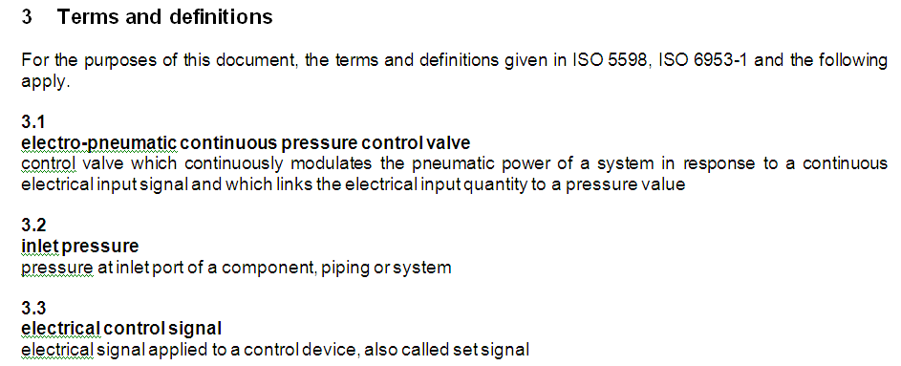For example:

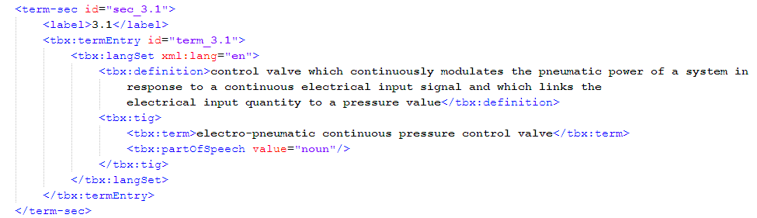Should be coded as:

**<tbx:partOfSpeech>** is mandatory in the DTD.

Possible values:

noun

verb

adj

adv

Use **@value="noun"** if not otherwise identifiable from the content.

### <tbx:example>

When coding with tbx, the "Example" keyword is to be removed from the content (use **<tbx:example>**).

For example:

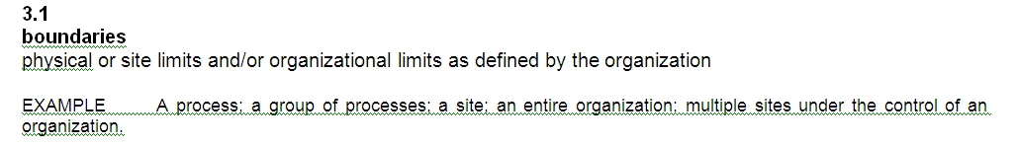Should be coded as:

|  |
| --- |
| <term-sec id="sec_3.1">  <label>3.1</label>  <tbx:termEntry id="term_3.1">  <tbx:langSet xml:lang="en">  <tbx:definition>physical or site limits... organization</tbx:definition>  <tbx:example>A process; a group... organization </tbx:example> |

### <tbx:note>

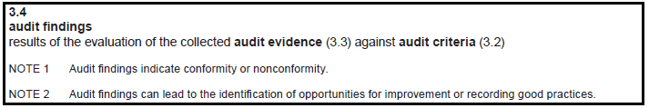When coding with tbx, the "Notes" keyword is to be removed from the content (use **<tbx:note>**).

Should be coded as:

|  |
| --- |
| <term-sec id="sec_3.4">  <label>3.4</label>  <tbx:termEntry id="term_3.4">  <tbx:langSet xml:lang="en">  <tbx:definition>results of the evaluation of the collected <tbx:entailedTerm  target="term_3.3">audit evidence (3.3)</tbx:entailedTerm> against  <tbx:entailedTerm target="term_3.2">audit criteria  (3.2)</tbx:entailedTerm>  </tbx:definition>  <tbx:note>Audit findings indicate conformity or nonconformity.</tbx:note>  <tbx:note>Audit findings can lead to the identification of opportunities for  improvement or recording good practices.</tbx:note> |

### <tbx:entailedTerm>

The **<tbx:entailedTerm>** element **should only be used** to mark up a term mentioned in the definition of another term.

The number of the term should be coded inside **<tbx:entailedTerm>**.

**@target** should be used if the reference is to a term that exists in the current document and use the **@id** of the referenced termEntry

For example:

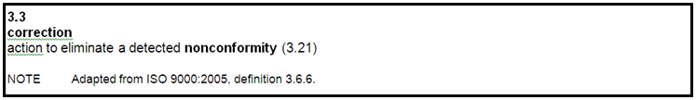Should be coded as:

|  |
| --- |
| <term-sec id=**"sec_3.3"**>  <label>**3.3**</label>  <tbx:termEntry id=**"term_3.3"**>  <tbx:langSet xml:lang=**"en"**>  <tbx:definition>**action to eliminate**  **a detected** <tbx:entailedTerm target=**"term_3.21"**>**nonconformity (3.21)**</tbx:entailedTerm>  </tbx:definition>  <tbx:note>**Adapted from** <std><std-ref>**ISO 9000:2005**</std-ref>**, definition 3.6.6**</std>**.**</tbx:note>  <tbx:tig>  <tbx:term>**correction**</tbx:term>  <tbx:partOfSpeech value=**"noun"**/>  </tbx:tig>  </tbx:langSet>  </tbx:termEntry>  </term-sec> |

For terms external to the document **@xtarget** should be used, and this attribute can be omitted in the conversion.

The terms will not be always visible in bold formatting. But those terms should also be coded as tbx:entailedterm

Ex: The term ‘salida’ is found under the 7.2 section but the term is not in bold formatting.





The term “salidas (6.18)” should also be coded inside “tbx:entailedterm”

### Cross references to the other related terms

The **tbx:crossReference** element is a hyperlinking element that points to the location of another term, usually a related term (including antonyms and homonyms). The element content contains the display text of the link. This element will be prepended with the label **Related term:** in the rendered output.

Do not use a formulation such as "Note: See xxx" for a cross-reference to another term.

**IMPORTANT: A crossReference cannot be embedded into a definition or an example. For that purpose, use** entailedTerm**.**

The target attribute is optional for crossReference, and mandatory for externalCrossReference.

This data category is repeatable; you can include as many as you want in an entry.

A crossReference can only occur at the langSet level, whereas an externalCrossReference can occur at either the langSet or the termEntry level.

### References to the other sections of the file [within tbx coding]

* Use <tbx:see> for references to other sections, tables, figures etc in the document
* If the reference is to only one addressable element (element has an **@id**) and it contains no other explanations, such as "see row 3 of table 3", then the entire reference can be replace with the **<tbx:see target="id of target element">**
* In all other cases provide the text as is (except a distinguishable label such as NOTE: or SEE:) in the **<tbx:see>** element.
* If the reference is still to only one element provide **@target**

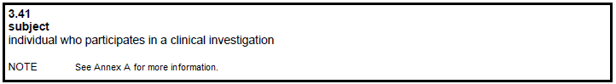

Should be coded as:

|  |
| --- |
| <term-sec id="sec_3.41">  <label>3.41</label>  <tbx:termEntry id="term_3.41">  <tbx:langSet xml:lang="en">  <tbx:definition>individual who participates in a clinical investigation </tbx:definition>  <tbx:see target="sec_A"/>  <tbx:tig>  <tbx:term>subject</tbx:term>  <tbx:partOfSpeech value="noun"/>  </tbx:tig>  </tbx:langSet>  </tbx:termEntry>  </term-sec> |

### Coding the source related to the term

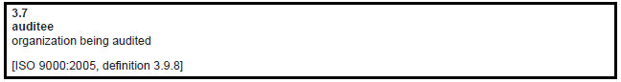For example:

Should be coded as:

|  |
| --- |
| <term-sec id="sec_3.7">  <label>3.7</label>  <tbx:termEntry id="term_3.7">  <tbx:langSet xml:lang="en">  <tbx:definition>organization being audited </tbx:definition>  <tbx:source>ISO 9000:2005, definition 3.9.8</tbx:source>  <tbx:tig>  <tbx:term>auditee</tbx:term>  <tbx:partOfSpeech value="noun"/>  </tbx:tig>  </tbx:langSet>  </tbx:termEntry>  </term-sec> |

Note: Square brackets or an existing label such as SOURCE should be removed from the text.

Do not code <std> for the standards found inside <tbx:source>

### Coding the type of the term.

<tbx:termType> and the **@value** should be coded in case the term appears to be one of the possible values:

* + acronym,
  + abbreviation,
  + fullForm,
  + symbol,
  + variant,
  + formula,
  + equation
* Full Form can be omitted.
* The difference between formula and equation is that equations contain the sign = in the mathematical term.
* The termType should be provided for any additional **<tig>** entry to the **<termEntry>**.
* DO NOT ASSIGN an @id to the <tig> element

Tip: An abbreviation is a shortening of a word or a phrase and an acronym is an abbreviation that forms a word.

For example:

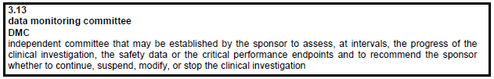Should be coded as:

|  |
| --- |
| <term-sec id="sec_3.13">  <label>3.13</label>  <tbx:termEntry id="term_3.13">  <tbx:langSet xml:lang="en">  <tbx:definition>independent committee that may be... investigation</tbx:definition>  <tbx:tig>  <tbx:term>data monitoring committee</tbx:term>  <tbx:partOfSpeech value="noun"/>  </tbx:tig>  <tbx:tig>  <tbx:term>DMC</tbx:term>  <tbx:partOfSpeech value="noun"/>  <tbx:termType value="abbreviation"/>  </tbx:tig>  </tbx:langSet>  </tbx:termEntry>  </term-sec> |

### subjectfield

When the definition of a term starts with text enclosed in 〈…〉, this should be tagged with subject field without capturing the brackets.



Should be coded as

<term-sec id="sec_3.6">  
 <label>3.6</label>  
 <tbx:termEntry id="term_3.6">  
 <tbx:langSet xml:lang="en">  
 <subjectfield>dispute resolution</subjectfield>  
 <tbx:definition> disagreement, arising from a  
 <tbx:entailedTerm target="term_3.3">complaint  
 (3.3)</tbx:entailedTerm>, submitted to a <tbx:entailedTerm  
 target="term_3.9">provider (3.9)</tbx:entailedTerm></tbx:definition>

**Special cases for tbx**

**Case 1**

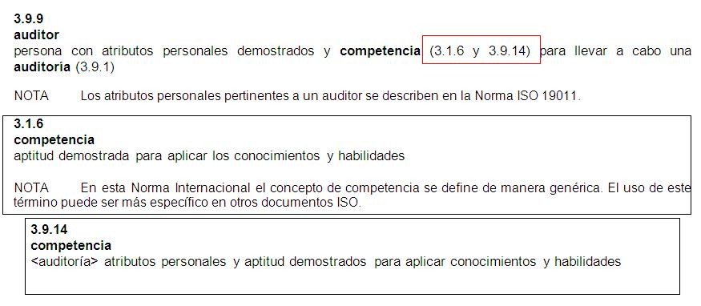In the following cases, use **only** the first **term_sec** value for the **tbx:entailedTerm@target**.

**Case 2**

The following should be coded as a list inside **tbx:note**, and the **tbx:entailedTerm** should be used to code the terms inside **<list>**.

For example:

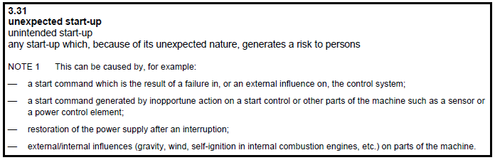Should be coded as:

|  |
| --- |
| <term-sec id="sec_3.31">  <label>3.31</label>  <tbx:termEntry id="term_3.31">  <tbx:langSet xml:lang="en">  <tbx:definition>any start-up which, because of its unexpected nature,  generates a risk to persons</tbx:definition>  <tbx:note>This can be caused by, for example: <list list-type="bullet">  <list-item>  <label>—</label>  <p>a start command... system;</p>  </list-item>  <list-item>  <label>—</label>  <p>a start command... element;</p>  </list-item>  <list-item>  <label>—</label>  <p>restoration of the power supply after an interruption;</p>  </list-item>  <list-item>  <label>—</label>  <p>external/internal influences... machine.</p>  </list-item>  </list>  </tbx:note> |

**Case 3**

The following program codes should be coded with the **<preformat>** element inside the **<tbx:note>** element.

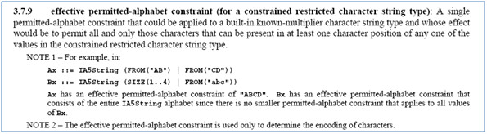

**Case 4**

The term should be coded inside **<tbx:tig>** with **<tbx:normativeAuthorization value="preferredTerm" />.** The highlighted section in red is the symbol of the term and should be coded inside the next **<tbx:tig>** with **<tbx:normativeAuthorization value="admittedTerm" />** and **<tbx:termType value="symbol" />.**

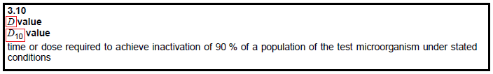For example:

Should be coded as:

|  |
| --- |
| <term-sec id="sec_3.10">  <label>3.10</label>  <tbx:termEntry id="term_3.10">  <tbx:langSet xml:lang="en">  <tbx:definition>time or dose required... conditions</tbx:definition>  <tbx:tig>  <tbx:term><italic>D</italic> value</tbx:term>  <tbx:partOfSpeech value="noun"/>  <tbx:normativeAuthorization value="preferredTerm"/>  ..............................<tbx:termType value="symbol"/>  </tbx:tig>  <tbx:tig>  <tbx:term><italic>D</italic><sub>10</sub> value</tbx:term>  <tbx:partOfSpeech value="noun"/>  <tbx:normativeAuthorization value="admittedTerm"/>  <tbx:termType value="symbol"/>  </tbx:tig>  </tbx:langSet>  </tbx:termEntry>  </term-sec> |

**Case 5**: **Multi-language terms**

For multilingual content, use separate **<tbx:langSet>** elements with appropriate @xml:lang to define the language of content.

# References

## Internal (Cross) Reference

### General

Internal references are made using **<xref>**.

The following attributes required to be used when coding **<xref>**:

1. ref-type – type of the link target

Possible values:

<xref ref-type="app">

<xref ref-type="bibr">

<xref ref-type="boxed-text">

<xref ref-type="disp-formula">

<xref ref-type="fig">

<xref ref-type="fn">

<xref ref-type="sec">

<xref ref-type="table">

<xref ref-type="table-fn">

Others include: chem, contrib, corresp, kwd, list, plate, scheme, statement, supplementary-material etc.

1. rid - id of the target

Ex: <xref ref-type="app" id="**sec_A**">

## Tables, Figures, Formulae

References to tables, figures, and formulae contained within the document should be made using the id in the respective **<table-wrap>**, **<fig >**, or **<disp-formula>** using the rid attribute and the ref-type attribute with a value of "table", "fig", or "disp-formula" respectively.

For example:

See Table 2 for an illustration.

Should be coded as:

<p>**See** <xref ref-type=**"table"** rid=**"tab_2"**>**table 2**</xref> **for an illustration.**</p>

## Graphics

Graphics files associated with the document should be referenced only in the single **<graphic>** that defines the figure, table, or formula that it represents as described in the instructions for coding these items. Any other reference to such graphics must be to the **<fig >**, **<table-wrap>** or **<disp-formula>** via its id attribute as described above.

## Term

References to terms contained within the document should be made using the id in the respective **<tbx:termEntry>**.

For example:

This term is defined in section 4.3.

is to be coded as:

<p>**This term is defined in** <xref ref-type=**"sec"** rid=**"term_4.3"**>**section 4.3**</xref>**.**</p>

### Footnotes

1. References to footnotes contained within the document (normally in the same page of the original) should be made using sequential id numbers in the respective **<fn>**
2. References to table footnotes (footnotes that are associated with the table and contained within the **<table-wrap>**) should have an id of the form TableNumber_FootnoteNumber, and the ref-type attribute will have a value of "table-fn" and the footnote id will be prefixed "table-fn".

Footnotes in the bibliography section should be coded with **<xref>** and be added to the document footnotes

Ex1:

Should be coded as:

|  |
| --- |
| <ref id="biblref_6">  <label>[6]</label>  <std><std-ref>ISO 9000</std-ref>:—<xref ref-type="fn" rid="fn_27"  ><sup>1)</sup></xref>, Quality management systems — Fundamentals and  vocabulary</std>  </ref> |

### Cross-references to the items in bibliography

The following references should be coded with **<xref>**:

1. @ref-type should be **‘bibr’**
2. @ids should be provided for the ref entries in the bibl section with the prefix "biblref_#" where # should match the visiual entry number [#]

Ex:1

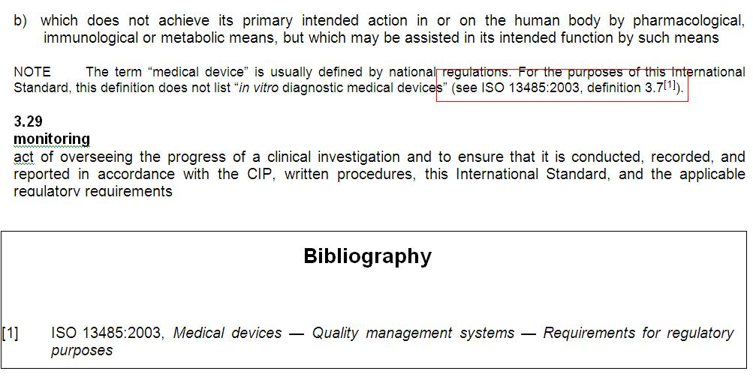

Ex2

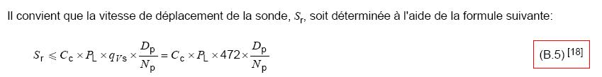

<label>**(B.5)** <sup>**[**<xref ref-type=**"bibr"** rid=**"bibl_18"**>**]**</sup></label>

### Other instances

Most of the instances which need **<xref>** will be found with the key words "see, shown in…". In addition, the following instances also need to be coded with **<xref>**.

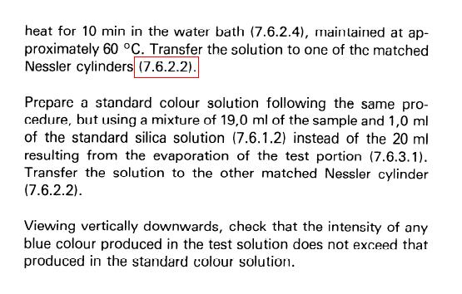

In the Table below, the notes ("see note 1", "see note 2"), do not need to be linked if these notes belong to the table (just listed below). 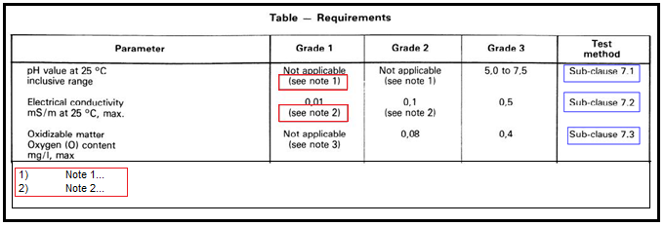However, the "Sub-clause 7.*" references should be marked-up using **<xref>** because they are available sections in the document.

## External Reference

### General

External references to the contents of other documents or standards are made using <std> if the reference is to a standard, or **<mixed-citation>** otherwise.

A reference to a standard can be recognized by its appearance in the form "ISO nnnn …".

Following pattern list specifies the permitted standards by ISO.

Parameter 1: ISO/ASTM|ISO/CEI|ISO/CIE|ISO/HL7|ISO/IEC/IEEE|ISO/IEC|ISO/IEEE|ISO/OCDE|ISO/OECD|CEI|IEC|ISO)

Parameter 2: [\s/]?

Parameter 3: (Data|Guide|ISP|IWA|PAS|R|TR|TS|TTA)?

Parameter 4: \s

Parameter 5: ([0-9]+)

Parameter 6: [-]?

Parameter 7: ([0-9A-Z]+|[0-9]-[0-9]+| \(all parts\))?

Parameter 8: ((:)([0-9]{4}|[\-—]+))?

Parameter 9: (/(Cor|Amd|Add|Suppl)\.([0-9]+)?((:)([0-9]{4}))?)?

Parameter 10: (/(Cor)\.([0-9]+)((:)([0-9]{4}))?)?\s?\)?

Parameter 11: (,(\s)*(.*))?

Only those instances which matches the above pattern will be recognized as a standard.

(bibliography and non-normative references will have exceptions)

The reference may be italicized; any formatting of the text of the reference should be coded.

The objective of conversion is to capture the text of these references accurately so that these can be further coded as references by ISO after their targets have been loaded into the ISO repository.

### Instances where the references are not needed

1. Leave all the instances of "ISO/TC [number]" in the content without coding <std>.

ISO/TC refers to the technical committee number and not to a standard.

Should be coded as:

|  |
| --- |
| <p><std><std-ref>ISO 21748</std-ref></std> was prepared by Technical Committee **ISO/TC 69**,  <italic>Applications of statistical methods</italic>, Subcommittee SC 6, <italic>Measurement  methods and results</italic>.</p> |

1. 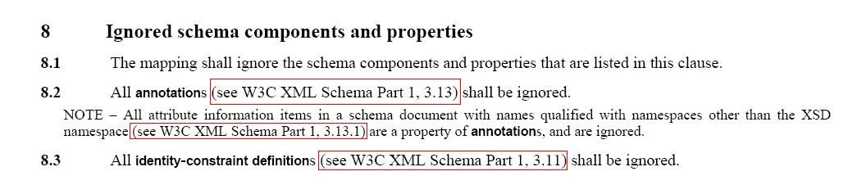<mixed-citation> can be used for the following references.

### Reference to standard in running text

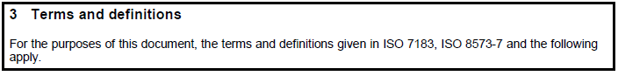For example:

Since these matches with the client provided pattern, these should be coded as:

|  |
| --- |
| <sec id="sec_3" sec-type="terms">  <label>3</label>  <title>Terms and definitions</title>  <p>For the purposes of this document, the terms and definitions given in  <std><std-ref>ISO 7183</std-ref></std>,  <std><std-ref>ISO 8573-7</std-ref></std> and the following apply.</p> |

They may also occur as a standard reference followed by a reference to a content section separated by comma, e.g.

Should be coded as:

<std><std-ref>**ISO/IEC Guide 98-3:2008**<std-ref>**, 7.3.1**</std>**;** <std><std-ref>**ISO 1234:2011** <std-ref>**, Equation (1)**</std>

### Reference to double references in running text

When two references are separated from a vertical bar, those will be categorized as double references. These will be checked separately by using the pattern provided.

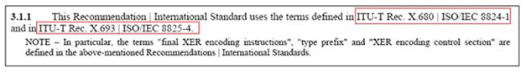

In this case, <std> will be coded if the pattern matches at least one of the standards before/after the ‘|’. And two  std-ref should be used within std

Ex: Code the double reference as;

<std><std-ref>**ITU-T Rec. X 680**</std-ref> **|** <std-ref>**ISO/IEC 8824-1**</std-ref></std>

### Reference to standard in Normative Reference clause

Where a reference to a standard appears in a list, the standard reference will usually be followed by the title of the standard, for example:

ISO 10094, *Title of the Standard*

is to be coded as:

<std><std-ref>ISO 10094</std-ref>, <title>Title of the Standard</title></std>

In normative references everything should be a <std>. It can be either matches with the provided patterns for std or follow the above format “standard, title”

Only if the above two two criteria can not be followed only the reference can be coded with <mixed-citation>

**Special cases of references**

**Case 1: Co-authored standards**

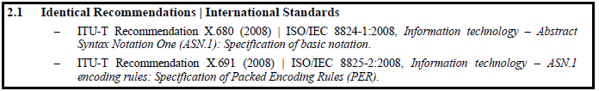For example:

Should be coded as:

|  |
| --- |
| <sec id="sec_2.1">  <label>2.1</label>  <title>Identical Recommendations | International Standards</title>  <ref-list>  <ref content-type="standard">  <label>—</label>  <std><std-ref>ITU-T  Recommendation X.680 (2008)</std-ref> |  <std-ref>ISO/IEC 8824-1:2008</std-ref>, <title>Information  technology — Abstract Syntax Notation One (ASN.1): Specification of  basic notation.</title></std>  </ref>  <ref content-type="standard">  <label>—</label>  <std><std-ref>ITU-T  Recommendation X.691 (2008)</std-ref> |  <std-ref>ISO/IEC 8825-2:2008</std-ref>, <title>Information  technology — ASN.1 encoding rules: Specification of Packed Encoding  Rules (PER).</title></std>  </ref>  </ref-list>  </sec>  </sec> |

**Case 2: Internet standards**

Because IETF RFCs are internet standards and the format used is clearly **<reference>**, **<title>**. Code using **<std>**. If for other references it is less obvious, use mixed-citation and code the visual presentation.

For example:

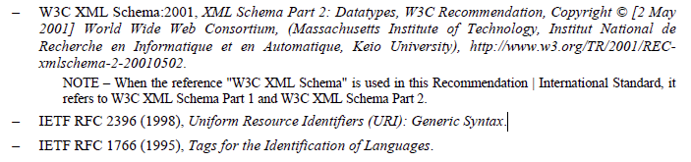Should be coded as:

|  |
| --- |
| <ref>  <label>**—**</label>  <std><std-ref>**IETF RFC**&#x00A0;**2396 (1998)**</std-ref>**,** <title>**Uniform Resource Identifiers (URI): Generic Syntax.**</title>  </std>  </ref> |

### Reference to standard in Bibliography

This is similar to the non-normative refence list. The references which matches with the patterns should be coded with stdOthers should be coded with <mixed-citaion>

Ex: The following references should be coded as <mixed-citation>.

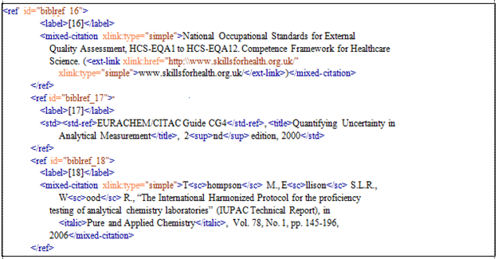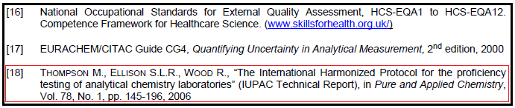

### URL <uri>

A url is coded using **<uri>**. The content of uri should be a valid uri. For example:

Further information is available at http://my.url on the interweb.

is to be coded as:

<p>**Further information is available at** <uri>**htt://my.url**</uri> **on the interweb.**</p>

### <ext-link>

Incomplete URLs, e.g., missing http:// and therefore not valid, should be tagged with [<ext-link>](http://www.iso.org/schema/isosts/v0.6/doc/n-wi50.html). **<ext-link>** is to be used when there is display text which hides the actual link.

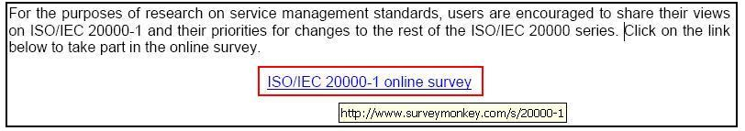**@ xlink:href** should be filled if the link information is available with the populated link. Otherwise do not use the **@xlink:href**.

Use:

|  |
| --- |
| <p style-type=”align-center”>  <ext-link xlink:href="**http://www.surveymonkey.com/s/20000-1**">ISO/IEC 20000-1 online survey</ext-link></p> |

### References that are not standards

A reference in the normative reference section that is not a standard should be coded as it appears (including formatting) using **<mixed-citation>**.

**Case 1:**

Should be coded as:

|  |
| --- |
| <ref>  <label>**—**</label>  <mixed-citation>**W3C XML**&#x00A0;**1.0:2000, Extensible Markup Language (XML)**&#x00A0;**1.0 (Second Edition), W3C Recommendation. Copyright [6 October**&#x00A0;**2000] World Wide Web Consortium, (Massachusetts Institute of Technology, Institut National de Recherche en Informatique et en Automatique, Keio University),** <uri xmlns:xlink=**"http://www.w3.org/1999/xlink"**>**http://www.w3.org/TR/2000/REC-xml-20001006**</uri>**.**  </mixed-citation>  </ref> |

**Case 2:**



Should be coded as:

|  |
| --- |
| <ref>  <label>**—**</label>  <mixed-citation>**W3C XML Schema:2001, XML Schema Part**&#x00A0;**2: Datatypes, W3C Recommendation. Copyright [`amp]copy; [2 May**&#x00A0;**2001] World Wide Web Consortium. (Massachusetts Institute of Technology, Institut National de Recherche en Informatique et en Automatique, Keio University),** <uri xmlns:xlink=**"http://www.w3.org/1999/xlink"**>**http://www.w3.org/TR/2001/REC-xmlschema-2-20010502<\uri>.**</mixed-citation>  <non-normative-note>  <label>**NOTE**</label>  <p>**When the reference "W3C XML Schema" is used in this Recommendation | International Standard, it refers to W3C XML Schema Part**&#x00A0;**1 and W3C XML Schema Part**&#x00A0;**2.**</p>  </non-normative-note>  </ref>  <ref>  <label>**—**</label>  <std><std-ref>**IETF RFC**&#x00A0;**2396 (1998)**</std-ref>**,** <title>**Uniform Resource Identifiers (URI): Generic Syntax.**</title>  </std>  </ref> |

# Images

When images available in EPS, use those as the base for the conversion to PNG, rather than recapturing from the pdf.

# Special Cases

## Document with different languages

This is related to the documents that have each sections of the document in different languages.

For example:

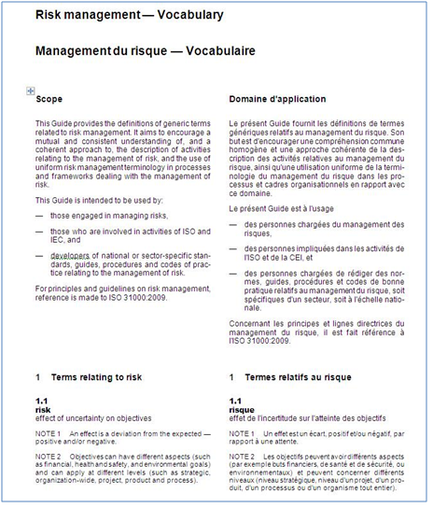

This document needs to be coded as two different documents.

The documents should be renamed with the suffix for language

For example:

**“044651_en,fr.Word.doc”** will be coded as **“044651_en.Word.doc”** & “**044651_fr.Word.doc”**

## Documents with comparisons of other standards

**Identifying comparison tables –**

Usually the comparison is done for two or more standards. And those table headers or table title contain the names of the standards(code of the standard) which are being compared.

Therefore, only the tables which their headers contain one or more standards(code of the standard) or when the table titles contain such standards(code), those will be considered as comparison tables.

This is applicable for all the languages.

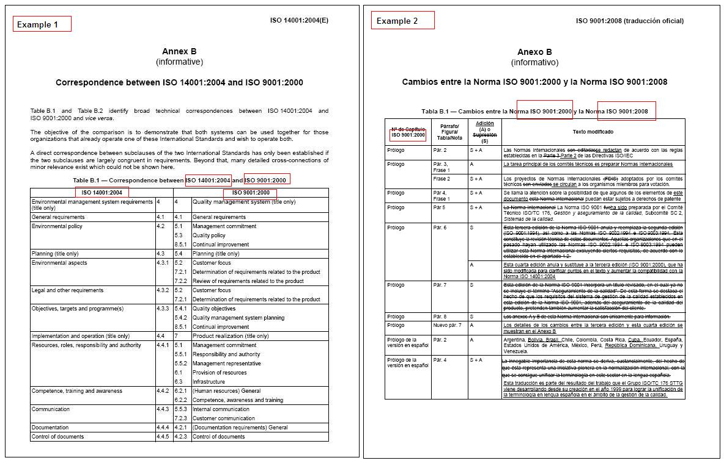

When coding the <table-wrap> for the comparison tables, following attribute and the values need to be used.

@content-type="comparison"

The following are some examples of documents comparing standards.

1. The following comparison table contains block level structures as figures and arrays. But these structures or the figures are not the actual document structure or the figures of the actual document.

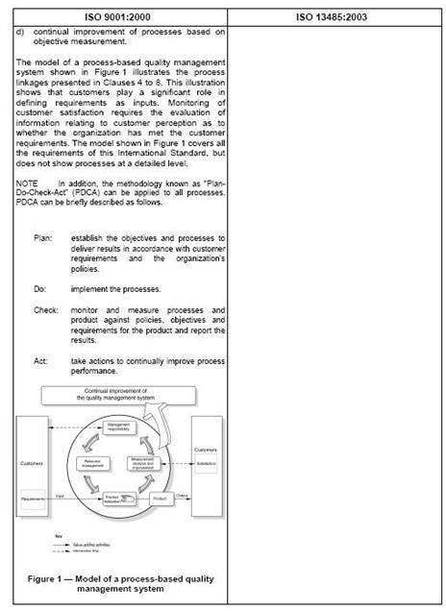

* Following block level elements can be used to code these structures inside comparison tables.
  + 1. disp-formula
    2. non-normative-note
    3. non-normative-example
    4. array
    5. fig
* When creating the id’s for these structures, following method need to be followed;

Use a prefix for i.ds: **cmp_columnNumber**_

So for figures in column 1 and 2, the id’s would be:

**cmp_1_fig1** and **cmp_2_fig1**

1. For following Only visual markup is needed for the following instances of the table, <std> or <non-normative-note> markup is not needed. (The table contains updates done to another document)

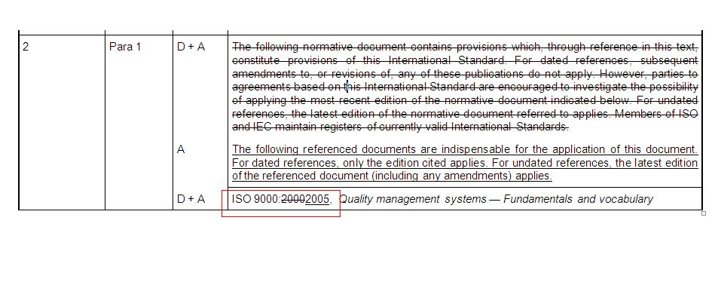

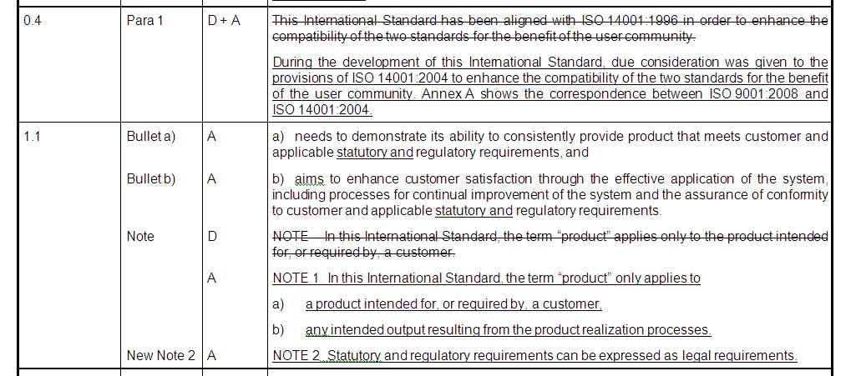

1. Comparison tables with source file contents:

In certain cases there are tables which compare the contents of the source standard with external standards. These tables can be only identified by comparing the standard (code) name of the source with the number/code of the standard in the table headers.

**For example**,the reference image contain a table from the standard ‘ISO 14001:2004(E)’ and in the table; the sections of the ‘ISO 14001:2004’ are compared with the ‘ISO 9001:2000’. In this case, we need to maintain the xref to local sections

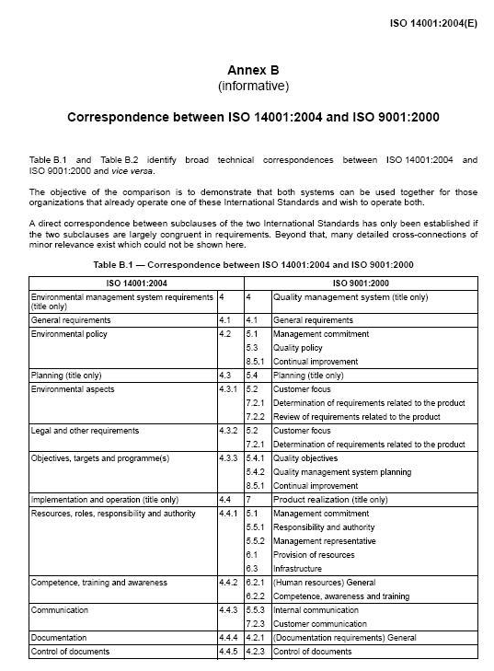

## Corrigendum (Amendment documents)

These are supplements (corrigenda or amendments) and they follow different drafting rules.

In most cases, they only contain one sec in the body (no **@id** or title needed). An empty <label/> can be used to create a valid <sec> element. Within the sec, use existing guidelines to render the visual. Here, the principle is visual before structure.

## Combination of Corrigendum and standard document structures

Code this using table-wrap within sec.

**REVISION HISTORY**

|  |  |  |
| --- | --- | --- |
| **Version No.** | **Date** | **Changes** |
| 0.0 |  | Draft Release |
| 0.1 | 08-11-2011 | Revisions according to the query answers |
| 0.2 | 09-11-2011 | Revisions according to the query answers |
| 0.3 | 18-11-2011 | Revisions according to the query answers |
| 0.4 | 24-11-2011 | Revisions according to the query answers |
| 0.5 | 30-11-2011 | Revisions according to the query answers |
| 0.6 | 27-12-2011 | Revisions according to the query answers |
| 0.7 | 16-01-2011 | Revisions according to new requirements |
| 0.8 | 22-02-2012 | Revisions according to feedback and new instructions |
| 1.1 | 03-05-2012 | Revisions according to feedback and new instructions |
|  | | |